Name: _____________________________________________ Period: ______ Date: ___________________________
USS Maine Conspiracy: Activity
As we have discussed the conspiracy concerning the explosion of the USS Maine, we cannot overlook the importance of yellow journalism. The reports of Pulitzer and Hearst helped to catapult the affairs taking place in Cuba into the living rooms and daily discussions of Americans throughout the country.
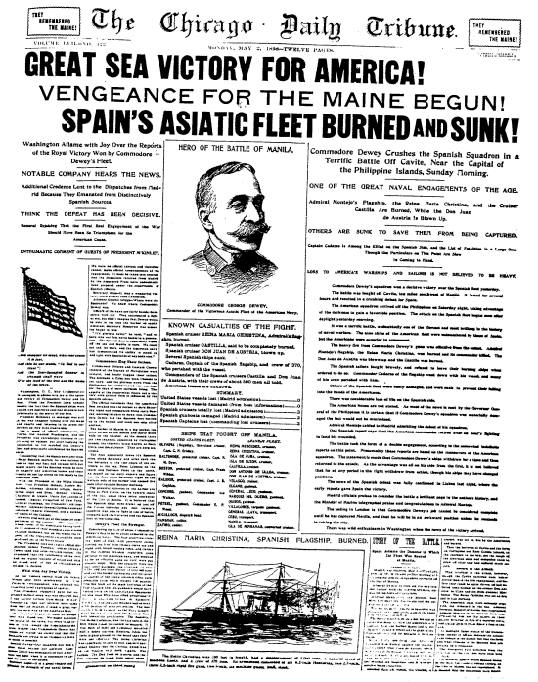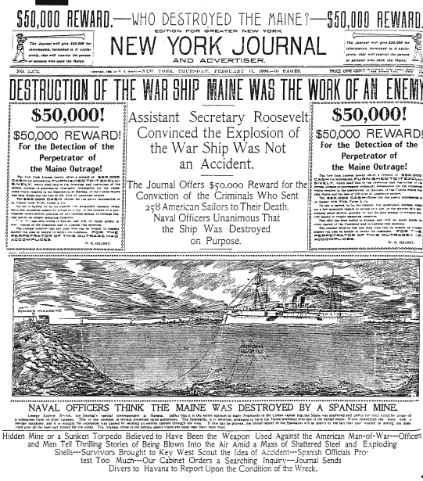
Your task: Create your own piece of yellow journalism as you report on the affairs of Cuba in 1898. Your article must take a definitive stance on the cause and group behind the explosion of the USS Maine. Your news article must be typed and fit an entire 8.5x11 sheet of white paper. Remember, yellow journalism is known for sensationalism, large headlines and bold pictures so be sure to include each in your news article.
You may use lecture and the textbook to help in the construction of your article.
Point Breakdown:
Picture: 2 pts
Headline: 2 pts
Content of Article: 12 pts
-This includes both:
1. facts concerning the explosion (6)
2. yellow journalism techniques (6)
Mechanics: 2 pts
Style/Focus: 2 pts
Total: 20 points

