Delivery
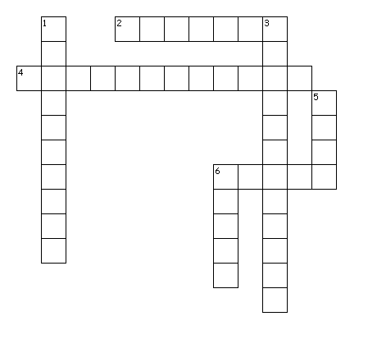
Across Clues
2. Equal weight, shoulders back, chin up, arms at side, feet shoulders width apart
4. Change in volume, rate, pitch
6. Synonym for composure
Down Clues
1. Speak so all can hear
3. High energy
5. How fast we speak
6. Musical wavelike note our voice produces

Created by Puzzlemaker at DiscoveryEducation.com

Across Answers: 2. Posture 4. Vocal Variety 6. Poise
Down Answers: 1. Projection 2. Enthusiastic 5. Rate 6. Pitch

