Adaptations for Pennsylvania Forests
There are many deciduous forest environments in Pennsylvania. “Deciduous” means that the trees change with the seasons. The temperature is very hot in the summer and below freezing in the winter. Sometimes there is a lot of rainfall, but other times, there is not much rain. Sunlight can reach tall plants, but the forest floor is mostly shady. Plants and animals must be adapted to survive the changes over the four seasons. Directions: Choose one plant and one animal that live in Pennsylvania forests from the ideas provided below. Use books or the Internet to find out about adaptations that the plant and animal have. Complete the worksheet on the next page.
Forest
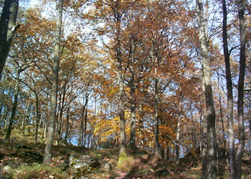
Eastern Chipmunk  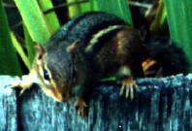 | Eastern Blue Jay  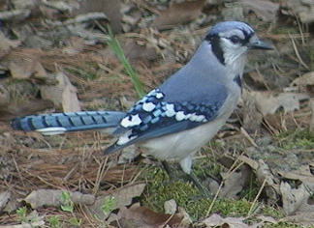 | White-Tailed Deer  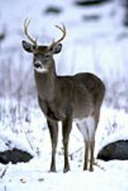
Shagbark Hickory Tree  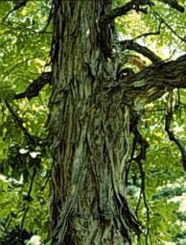 | White Birch Tree  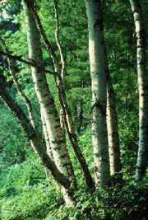 | Lady Fern  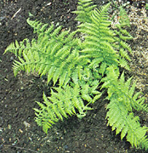
Name _____________________________________
Adaptations for Pennsylvania Forests
Questions
Animal’s Name: _____________________________________
1. What does this animal need in order to survive?

2. Name two adaptations of this animal:

3. How do these adaptations help the plant survive in the forest?

Plant’s Name: _______________________________________
4. What does this plant need in order to survive?

5. Name two adaptations of this plant:

6. How do these adaptations help the plant survive in the forest?

7. What is the difference between behavioral and structural adaptations?

8. Give one example of a behavioral and a structural adaptation for living things in Pennsylvania forests.

9. What are two ways YOU are adapted to survive the changes in seasons?

Name _____________________________________

ANSWER KEY
Adaptations for Pennsylvania Forests
Questions
Animal’s Name: Eastern chipmunk, Eastern blue bird, or white-tailed deer
1. What does this animal need in order to survive? Food, water, shelter, air
2. Name two adaptations of this animal: Answers will vary. The chipmunk has protective coloration (camouflage), it stores food for the winter, and it hibernates. The Eastern blue bird migrates and it has a beak that allows it to catch insects to eat. The white-tailed deer has protective coloration (camouflage), and it has fur to keep it warm in the winter.
3. How do these adaptations help the plant survive in the forest? Answers will vary depending on the animal chosen, but they should relate the adaptations from question 2 to survival in the forest.

Plant’s Name: white birch tree, shagbark hickory tree, or lady fern
4. What does this plant need in order to survive? Sunlight, water, food, air
5. Name two adaptations of this plant: Answers will vary. The white birch and shagbark hickory have thick bark to protect against cold winters, they have broad leaves to capture sunlight energy, they drop their leaves to retain water, and they have deep roots to reach water under the ground. The lady fern has broad leaves to capture more sunlight on the shady forest floor, and its leaves come out in early spring before the trees’ leaves come out.
6. How do these adaptations help the plant survive in the forest? Answers will vary depending on the plant chosen, but they should relate the adaptations from question 2 to survival in the forest.
7. What is the difference between behavioral and structural adaptations?
Behavioral adaptations are actions animals take to survive in their environments. Examples are hibernation, migration, and instincts.
Structural Adaptations are characteristics in a plant or in an animal’s body that helps it to survive in its environment.
8. Give one example of a behavioral and a structural adaptation for living things in Pennsylvania forests.
Behavioral examples: Chipmunks store food for the winter and birds fly south in the winter because they can find more food.
Structural examples: protective coloration (camouflage) and dropping leaves in the winter.
9. What are two ways YOU are adapted to survive the changes in seasons? Answers will vary.
Sources of Images:
Forest
www.rbcarlton.com/forest002.jpg
Eastern Chipmunk
www.blueplanetbiomes.org/images/Chipmunk3.jpg
White-Tailed Deer
www.blueplanetbiomes.org/images/deers.jpg
Eastern Blue Jay
www.mynaturephotos.com/images/BlueJay.jpg
Shagbark Hickory Tree
www.blueplanetbiomes.org/images/shagbark_hickory.jpg
White Birch
www.blueplanetbiomes.org/images/betula_papyrifera.jpg
Lady Fern
www.blueplanetbiomes.org/images/lady_fern.jpg

