If You Can't Run, You've Got to Hide!
I am sure that the most famous person you know that hides for a living is Waldo. Here is a picture of Waldo.
Before we get started see if you can find Waldo in these pictures. This will test your predator skills of looking closely and finding something that is very well hidden!
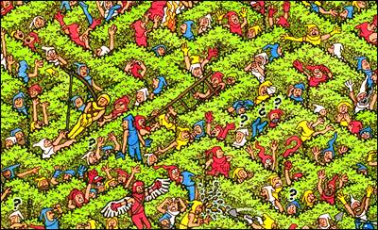 | 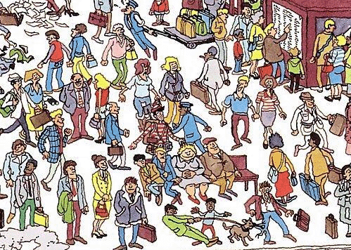
Some animals hide in plain sight in order to survive in the wild! You might be thinking, how does this work!? When you play hide-n-seek can you just sit in the middle of the room? No, you will be found immediately. The difference between humans and some animals who hide in the open is that these animals have colors and patterns that allow them to disappear, almost becoming invisible before your very eyes.
Source: http://chalk.richmond.edu/education/projects/webunits/adaptations/images/maze07.jpg

