Camouflage It Activity
Materials: color ads from the newspaper or magazines, a butterfly pattern, scissors, glue
Objective: To demonstrate how camouflage works by trying to camouflage butterflies.
Instructions: Take several color ads from the Sunday newspaper inserts or a magazine.
Now make a pattern for a small butterfly or use the one below. You can make one easily by folding a piece of paper and drawing half a butterfly on the fold line. Then cut out the folded butterfly.
Pick one large ad to use as your environment. Look at the colors and patterns in the ad, including the words. Now go through the other ads and look for similar colors and letters. Using your butterfly pattern, trace butterflies onto the different ads and cut them out. Make sure some butterflies are solid colors and some are patterned.
Now try placing your butterflies in your environment. Do your best to try and hide them. Some will stand out and that’s okay. The butterflies don’t have to be an exact match; they just have to blend into the environment. If you want to make it trickier, you can vary the size of the butterflies. Look at the sample shown.
You can use this activity in two ways. You can create a camouflage page and then have the children try to find all the butterflies. Or, you can have the children create their own pages. There is more information on camouflage at http://www.blockpub.com/pages/rainbow/RWcamouflage.html

There are 7 butterflies hidden on this page. Can you find them all?
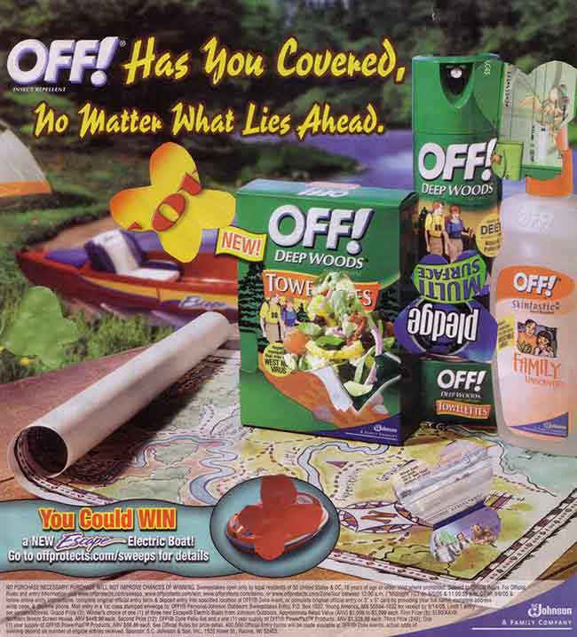
Source: www.blockpub.com/pages/rainbow/RWcamouflageit.html

Butterfly Pattern (Copy it and have kids trace around it and cut it out.)

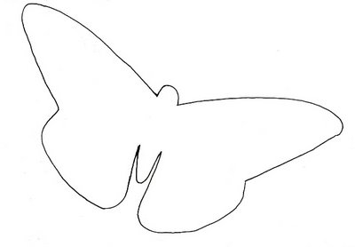

http://1.bp.blogspot.com/_fxPfm-bS24M/SI49xu4O7TI/AAAAAAAAAkY/YZkv5PZqDqg/s400/Butterfly+outline.jpg

