Scale and Balance Worksheet
 | Scale | Balance
 | 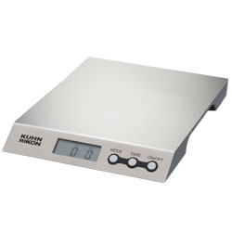 | 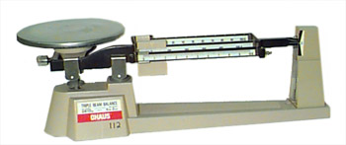
How does it work?

Does it work the same on Earth and on the moon?
Does it actually measure mass or weight?

Scale and Balance Worksheet KEY
 | Scale | Balance
How does it work? | Measures the weight of an object by the force exerted on the scale from Earth’s gravitational pull. | Measures mass of an object by balancing the scale against a known (standardized) mass, which is set into the balance.
Does it work the same on Earth and on the moon? | No, the moon has less gravity so less force will be exerted on the scale, decreasing the weight. | Yes
Does it actually measure mass or weight? | weight | mass

