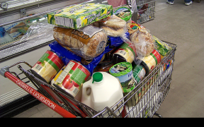
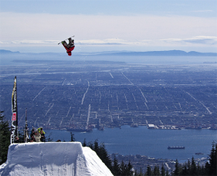

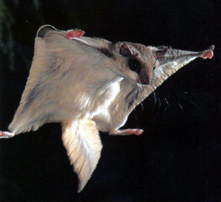
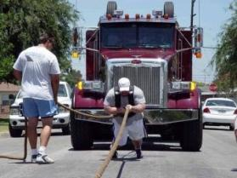

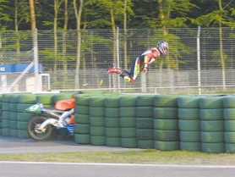

References:
Shopping cart picture
http://www.hoothollerscribble.com/

Snowboard picture
http://pixdaus.com/single.php?id=46151

Flying squirrel picture
http://theora.com/msdb.php/OriginOfSpecies/msdbNavPage/62

Truck pull picture
http://picsdigger.com/keyword/semi%20truck%20pulls/

Pool shot picture
http://www.billiardclick.com/?tag=billiards-drills

Motorcycle picture
http://www.hamovhotov.com/fun/?m=200706&paged=44

