Elodea Leaf Cells Under a Microscope
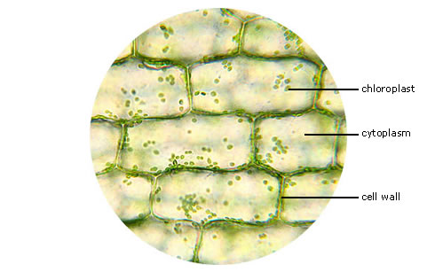

Source: http://www.southbank.net/blogs/staff/darinm/Elodea_Leaf_Cells_400x.jpg.

