Name: ____________________________________________ Date: _________________
Cambrian Fossils
Directions: For each fossil shown below, a. write the fossil’s name, and b. write its characteristics. Choose the correct fossil names and characteristics from the chart below.
Fossil Names | Characteristics
Echinoderms | Marine invertebrates with bivalve shells that have a pair of arms with tentacles inside; also called “lampshells.”
Trilobites | Invertebrates that have a fleshy, muscular body. Includes snails, bivalves, squids, and octopuses.
Mollusks | A group of marine invertebrates that includes starfish, brittle stars, basket stars, sea cucumbers, sand dollars, and sea urchins. Echinoderm means “spiny skin.”
Brachiopods | An extinct group of arthropods with segments of the body divided into three lobes.
1. 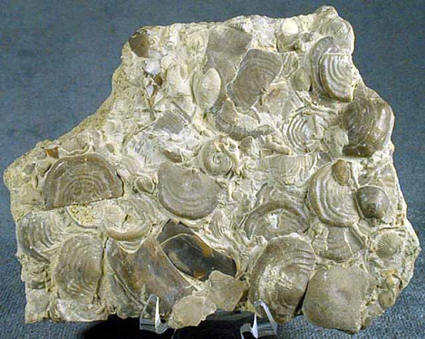
a. ___________________________________________________________________________
b. ___________________________________________________________________________
2. 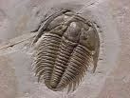

a. ___________________________________________________________________________
b. ___________________________________________________________________________

3. 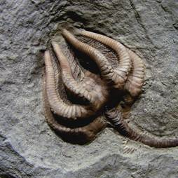
a. ___________________________________________________________________________
b. ___________________________________________________________________________

4. 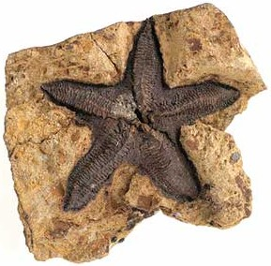
a. ___________________________________________________________________________
b. ___________________________________________________________________________

Answer KEY
Cambrian Fossils
Directions: For each fossil shown below, a. write the fossil’s name, and b. write its characteristics. Choose the correct fossil names and characteristics from the chart below.
Fossil Names | Characteristics
Echinoderms | A group of marine invertebrates that includes starfish, brittle stars, basket stars, sea cucumbers, sand dollars, and sea urchins. Echinoderm means “spiny skin.”
Trilobites | An extinct group of arthropods with segments of the body divided into three lobes.
Mollusks | Invertebrates that have a fleshy, muscular body. Includes snails, bivalves, squids, and octopuses.
Brachiopods | Marine invertebrates with bivalve shells that have a pair of arms with tentacles inside; also called “lampshells.”
1.
a. Brachiopods
b. Marine invertebrates with bivalve shells that have a pair of arms with tentacles inside; also called “lampshells.”
2.

a. Trilobites
b. An extinct group of arthropods with segments of the body divided into three lobes.

3.
a. Mollusks
b. Invertebrates that have a fleshy, muscular body. Includes snails, bivalves, squids, and octopuses.
4.
a. Echinoderms
b. A group of marine invertebrates that includes starfish, brittle stars, basket stars, sea cucumbers, sand dollars, and sea urchins. Echinoderm means “spiny skin.”

