Pond Water Lab Activity
Microscope Safety: Always handle microscopes and slides carefully. Ask if you need help with the microscope. Begin at the lowest magnification on the microscope. Tie back long hair. Remove glasses before using the microscope.
Directions:
1. Study the images of common unicellular and multicellular pond organisms on your Guide to Pond Water Organisms handout.
2. Use the microscope to find five different organisms in your sample of pond water. If you do not see that many organisms, you may need to add another drop of pond water to your slide or focus your microscope.
3. For each of the five organisms:
- draw it,
- label it with its name,
- label it as unicellular or multicellular, and
- write how you think it gets food and how it moves.
4. Use the space below and the back of this handout to record your drawings and observations.

Answer KEY
Pond Water Lab Activity
Directions:
1. Be sure to review how to use a microscope and lab safety precautions.
2. Model how to prepare a slide with the eyedropper, the pond water, and slide. Model how to place the slide on the microscope and adjust the focus at the lowest magnification.
3. Before they begin, direct students to read through the lab worksheet. Answer any questions students may have.
4. Assist students as they prepare their slides and use microscopes.
5. Explain to students that they may be able to observe many of the pond organisms fulfilling their needs by eating, moving about in search of food, or moving water in order to obtain oxygen.

Answers will vary, depending on the organisms that students find in their water samples. Some of the organisms students might see are described below.

Answer KEY, continued
Guide to Pond Water Organisms
Unicellular Organisms | Multicellular Organisms
Chlamydomonas  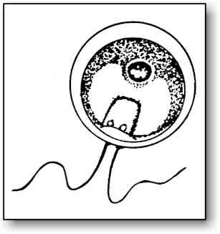 | Rotifers  Use “halo” of fine hairs to wave food particles into the mouth.  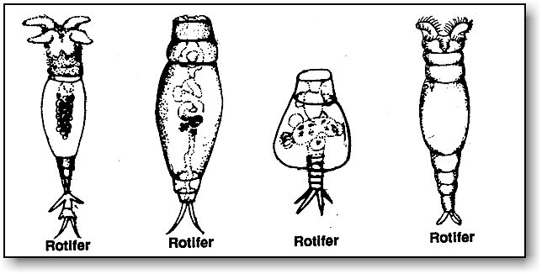
Euglena  Makes its own food by photosynthesis, obtains oxygen directly from the water. Uses flagella for movement.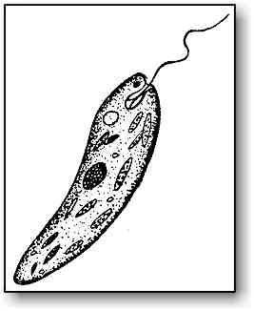 | Daphnia (“water flea”)  Eats algae and bacteria in the water, breathes by pumping water over its gills.  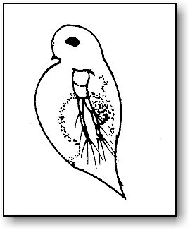
Volvox (a colony of single-celled organisms)  Single cells are connected together in a hollow sphere. Makes its own food by photosynthesis, obtains oxygen directly from the water.  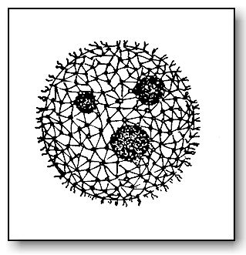 | Cyclops  A type of crustacean related to lobsters, crabs and shrimp. Invertebrates with a hard outer shell. Able to swim around.  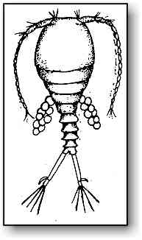
Amoeba  Takes in other smaller unicellular organisms, obtains food and oxygen directly from the water.  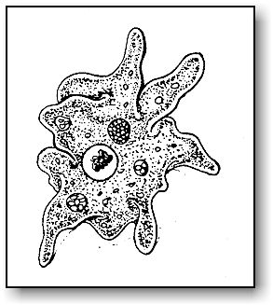 | Hydra  Uses tentacles and stinging cells to catch smaller organisms, obtains oxygen directly from the water.  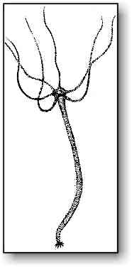
Stentor  Takes in other smaller unicellular organisms, obtains food and oxygen directly from the water. Uses cilia for movement.  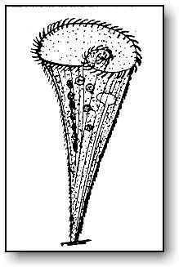 | Cypris  A type of crustacean related to mussels and shrimp. Small with a hard outer shell. Swim smoothly with appendages from between the two halves of their shells. When disturbed, they often withdraw their limbs into the shell and clamp the halves together.  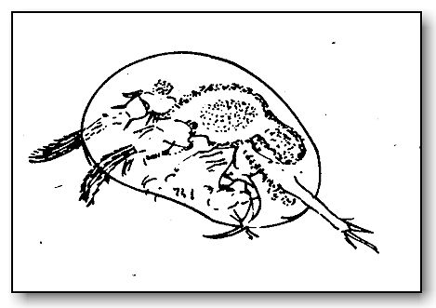
Paramecium  Takes in other smaller unicellular organisms; obtains food and oxygen directly from the water. Uses cilia for movement.  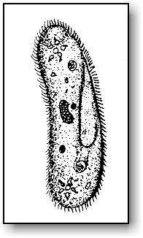 | Chaetonotus  Unsegmented, worm-like aquatic invertebrates. Covered with cilia they use for forward and backward movement. Sometimes confused with paramecia. Long, flat body with a head and a divided tail. Eat by sucking food into the mouth.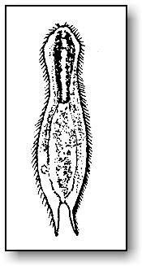
Source of all images: www.microscope-microscope.org/applications/pond-critters/pond-critters.htm

