Name ________________________________
Daphnia Lab Worksheet
Levels of Biological Organization–Introduction
Living things are complicated! They are made of many small and large pieces. But it is this variety and complexity that allow them to do really difficult things like think, grow, and make copies of themselves (reproduce). Nonliving things like chairs can’t run around or reproduce because they don’t have all of these complicated pieces. In this lab, you look at how we organize all the pieces from largest to smallest in what are called levels of biological organization by thinking about a human example, then looking at an example of a crustacean called Daphnia (water flea). Why can’t a chair reproduce? ________________________________________.

Levels of Biological Organization and Reproduction–Human Example
Definitions:

Organism = ____________________________________________________________
Organ system = ___________________________________________________
Organ = ___________________________________________________
Tissue = _____________________________________________
Cell = _________________________________________
Organelle = _______________________________
Molecule = ________________________

Fill in the missing words from the box below to complete the paragraph.
uterus, human, nucleus, epithelial and muscle, reproductive, DNA, epithelial

The organism that most likely produced you was a ______________. This was possible because of an organ system they possess called the ________________ system. The organ in the system that is most directly involved incubating the offspring was the _______________. If we look into this organ we see that it is made of different tissues or cells working together such as _______________________ tissues. Epithelial tissue is made of lots of individual cells called _______________ cells working together. These cells often form the lining of organs. Each of these cells is full of different parts called organelles that do different jobs inside the cell. For example, the organelle that holds and protects the cell’s instructions for making new parts is called the ________________. The specific molecule that is the directions is given to us from our parents and is called _________________.

Levels of Biological Organization and Reproduction–Daphnia Example
Purpose
You will now apply these same levels of organization to look at the similarities and differences between daphnia (water fleas) and human reproduction. You will identify different parts of the daphnia and check to see if they are pregnant, then compare their life cycle to a human’s.

Materials:
- microscope
- depression slide
- eyedropper
- beaker with water
- daphnia
- small piece of tissue or paper towel

Procedure
- Get the required materials.
- Look at the daphnia under the microscope on the lowest power. If the daphnia is swimming around too much you will need to suck up some of its water. Carefully touch the corner of the paper towel to the pool of water on the slide. The paper towel will quickly absorb the water so don’t hold it there for very long. Also, don’t suck up the daphnia! They need the oxygen in the water to live so add some back with the eyedropper if they become too dry. There should be enough water so that they are wet but can’t really swim around.
- Look at the diagram of the daphnia and find your daphnia’s brood chamber. Start on low power and go up to higher powers if you like. Determine if the daphnia is pregnant and record your findings on the table below. If it is pregnant there will be eggs in the brood chamber. Don’t confuse the legs with the brood chamber! The legs are on the same side as the eye and mouth, the brood chamber is toward the ‘back’. You can usually see a single black spot on each baby in the brood chamber. The black spot is the baby’s eye.
- Return your daphnia and obtain another. Repeat above steps until you are finished. No daphnia should be left on the microscope for more than a few minutes without water since they will dry out and die.
- Most daphnia will NOT be pregnant. If you are lucky and find a pregnant one, share it with others. Keep it wet though. Put all materials away before moving on to the analysis questions.

Data
Daphnia name  (make it up) | Pregnant? (Yes/No) | If pregnant, how many offspring?
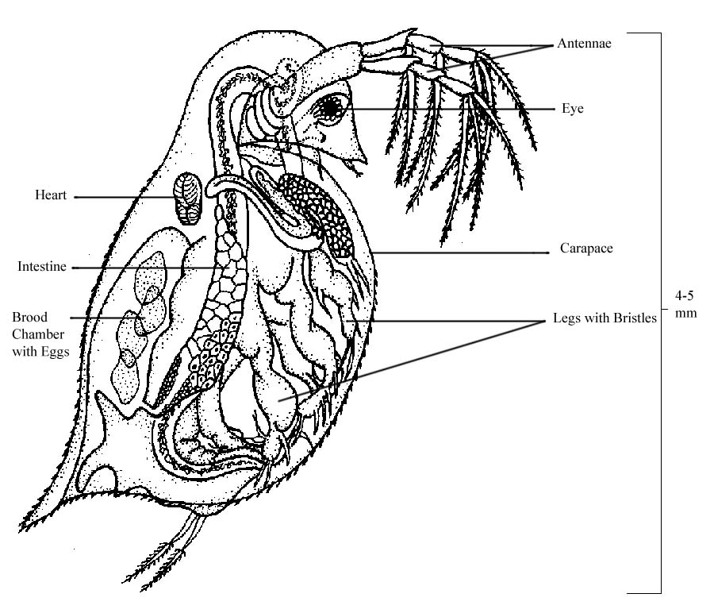

Analysis
Levels of Biological Organization
- What was the organism you were looking at under the microscope?
- In what ways is the brood chamber similar to the human uterus?
- In which level of biological organization would the brood chamber be classified?
- What are two other organs that you were able to see on the daphnia?
- You microscope allows you to see tissues, with a more powerful microscope and stains what would be the next smallest level you could see?
- Could you see the daphnia’s individual DNA molecules? Explain how you know.
Reproduction and Life Cycles
Study and use the life cycle diagram that has both the human and Daphnia life cycles to answer the following questions.

- In the human life cycle, what do females produce?
- In the human life cycle, what do males produce?
- What is it called when these two products come together?
- What molecule would be in the sperm and egg that has the genetic directions for how to make the offspring?
- During sexual reproduction, does the offspring inherit traits from one parent, or both?
- What other form of reproduction do daphnia have that humans do not?
- Are males necessary for this type of reproduction?
- During asexual reproduction does the offspring inherit traits from one parent, or both?
- If you could test daphnia offspring DNA, how could you tell if they were produced sexually or asexually?

Answer KEY
Daphnia Lab Worksheet
Levels of Biological Organization–Introduction
Living things are complicated! They are made of many small and large pieces. But it is this variety and complexity that allow them to do really difficult things like think, grow, and make copies of themselves (reproduce). Nonliving things like chairs can’t run around or reproduce because they don’t have all of these complicated pieces. In this lab, you look at how we organize all the pieces from largest to smallest in what are called levels of biological organization by thinking about a human example, then looking at an example of a crustacean called Daphnia (water flea). Why can’t a chair reproduce? It lacks the small complex pieces to do so.

Levels of Biological Organization and Reproduction–Human Example

Definitions:

Organism = A living thing.
Organ system = A group of organs working together.
Organ = A group of tissues working together.
Tissue = A group of cells working together.
Cell = A collection of organelles surrounded by a membrane.
Organelle = A part of the cell with a specific function.
Molecule = Two or more atoms bonded together.
Fill in the missing words from the box below to complete the paragraph.
uterus, human, nucleus, epithelial and muscle, reproductive, DNA, epithelial

The organism that most likely produced you was a human. This was possible because of an organ system they possess called the reproductive system. The organ in the system that is most directly involved incubating the offspring was the uterus. If we look into this organ we see that it is made of different tissues or cells working together such as epithelial and muscle tissues. Epithelial tissue is made of lots of individual cells called epithelial________ cells working together. These cells often form the lining of organs. Each of these cells is full of different parts called organelles that do different jobs inside the cell. For example, the organelle that holds and protects the cell’s instructions for making new parts is called the nucleus. The specific molecule that is the directions is given to us from our parents and is called DNA.

Levels of Biological Organization and Reproduction–Daphnia Example
Purpose
You will now apply these same levels of organization to look at the similarities and differences between Daphnia (water fleas) and human reproduction. You will identify different parts of the Daphnia and check to see if they are pregnant, then compare their life cycle to a human’s.

Materials:
- microscope
- depression slide
- eyedropper
- beaker with water
- daphnia
- small piece of tissue or paper towel

Procedure
- Get the required materials.
- Look at the daphnia under the microscope on the lowest power. If the daphnia is swimming around too much you will need to suck up some of its water. Carefully touch the corner of the paper towel to the pool of water on the slide. The paper towel will quickly absorb the water so don’t hold it there for very long. Also, don’t suck up the daphnia! They need the oxygen in the water to live so add some back with the eyedropper if they become too dry. There should be enough water so that they are wet but can’t really swim around.
- Look at the diagram of the daphnia and find your daphnia’s brood chamber. Start on low power and go up to higher powers if you like. Determine if the daphnia is pregnant and record your findings on the table below. If it is pregnant there will be eggs in the brood chamber. Don’t confuse the legs with the brood chamber! The legs are on the same side as the eye and mouth, the brood chamber is towards the ‘back’. You can usually see a single black spot on each baby in the brood chamber. The black spot is the baby’s eye.
- Return your daphnia and obtain another. Repeat above steps until you are finished. No daphnia should be left on the microscope for more than a few minutes without water since they will dry out and die.
- Most daphnia will NOT be pregnant. If you are lucky and find a pregnant one, share it with others. Keep it wet though. Put all materials away before moving on to the analysis questions.

Data
Daphnia name  (make it up) | Pregnant? (Yes/No) | If pregnant, how many offspring?
Answers will vary.

Analysis
Levels of Biological Organization
- What was the organism you were looking at under the microscope? Daphnia
- In what ways is the brood chamber similar to the human uterus? It holds the offspring.
- In which level of biological organization would the brood chamber be classified? Organ
- What are two other organs that you were able to see on the daphnia? Answers will vary.
- You microscope allows you to see tissues, with a more powerful microscope and stains what would be the next smallest level you could see? Cell
- Could you see the daphnia’s individual DNA molecules? Explain how you know. No, if you can’t see cells, you can’t see things even smaller.

Reproduction and Life Cycles
Study and use the life cycle diagram that has both the human and Daphnia life cycles to answer the following questions.
- In the human life cycle, what do females produce? Eggs
- In the human life cycle, what do males produce? Sperm
- What is it called when these two products come together? Sexual reproduction/fertilization
- What molecule would be in the sperm and egg that has the genetic directions for how to make the offspring? DNA
- During sexual reproduction, does the offspring inherit traits from one parent, or both? Both (sperm and egg)
- What other form of reproduction do daphnia have that humans do not? Asexual
- Are males necessary for this type of reproduction? No
- During asexual reproduction does the offspring inherit traits from one parent, or both? There is only one parent.
- If you could test daphnia offspring DNA, how could you tell if they were produced sexually or asexually? If the offspring DNA matches the parent exactly it must be asexual.

