Spontaneous Generation Diagram

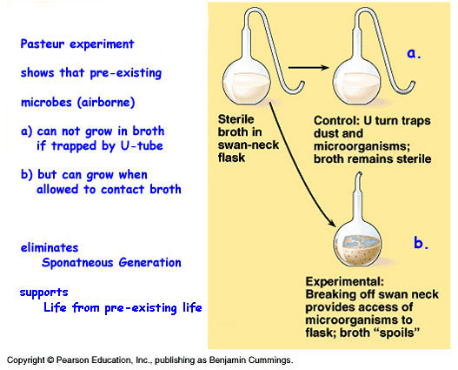

Source: www.bio.miami.edu/~cmallery/150/unity/c26x9pasteur-spontgen2.jpg

