Name ______________________________________________
Lentic and Lotic Ecosystems Worksheet
Directions: Answer the questions below.
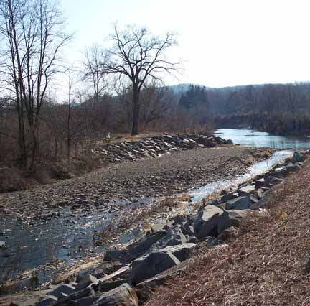 | 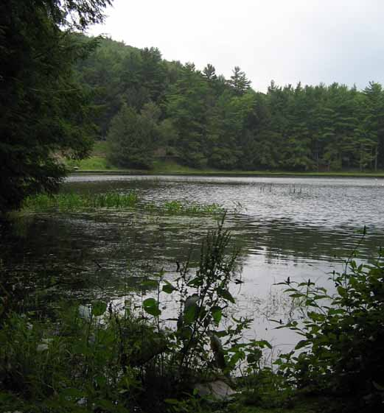
Tioga River (looking SE) Mansfield, Tioga County, Pennsylvania  Source: www.mrsoshouse.com/enviro02/photo3.html | Halfway Lake is fed by springs and creeks at Raymond B. Winter State Park, Union County, Pennsylvania  Source: www.mrsoshouse.com/water/w33.html

1. Label both of the photos above as “lentic” or “lotic” in the spaces above the photos.
2. What kinds of plants and animals would you expect to find in and around Tioga River?

3. What kinds of plants and animals would you expect to find in and around Halfway Lake?

4. Three kinds of lentic ecosystems:

5. Name one lentic ecosystem in your local area:

6. Three kinds of lotic ecosystems:

7. Lotic ecosystems have still waters or flowing waters (circle the correct words).

8. Name one lotic ecosystem in your local area:

9. Describe two differences between a lake and a stream:

10. Is a spring a lotic or lentic ecosystem? Why?

Lentic and Lotic Ecosystems Worksheet KEY
Directions: Answer the questions below.
Lotic | Lentic
Tioga River (looking SE) Mansfield, Tioga County, Pennsylvania  Source: www.mrsoshouse.com/enviro02/photo3.html | Halfway Lake is fed by springs and creeks at Raymond B. Winter State Park, Union County, Pennsylvania  Source: www.mrsoshouse.com/water/w33.html

1. Label both of the photos above as “lentic” or “lotic” in the spaces above the photos.
2. What kinds of plants and animals would you expect to find in and around Tioga River? Answers will vary.
3. What kinds of plants and animals would you expect to find in and around Halfway Lake? Answers will vary.
4. Three kinds of lentic ecosystems: pond, lake, marsh

5. Name one lentic ecosystem in your local area: Answers will vary.

6. Three kinds of lotic ecosystems: river, creek, stream

7. Lotic ecosystems have still waters or flowing waters (circle the correct words).

8. Name one lotic ecosystem in your local area: Answers will vary.

9. Describe two differences between a lake and a stream: Answers will vary, but students should understand that lakes are lentic (still) and streams are lotic (flowing).

10. Is a spring a lotic or lentic ecosystem? Why? A spring is a lotic ecosystem because it has flowing water.

