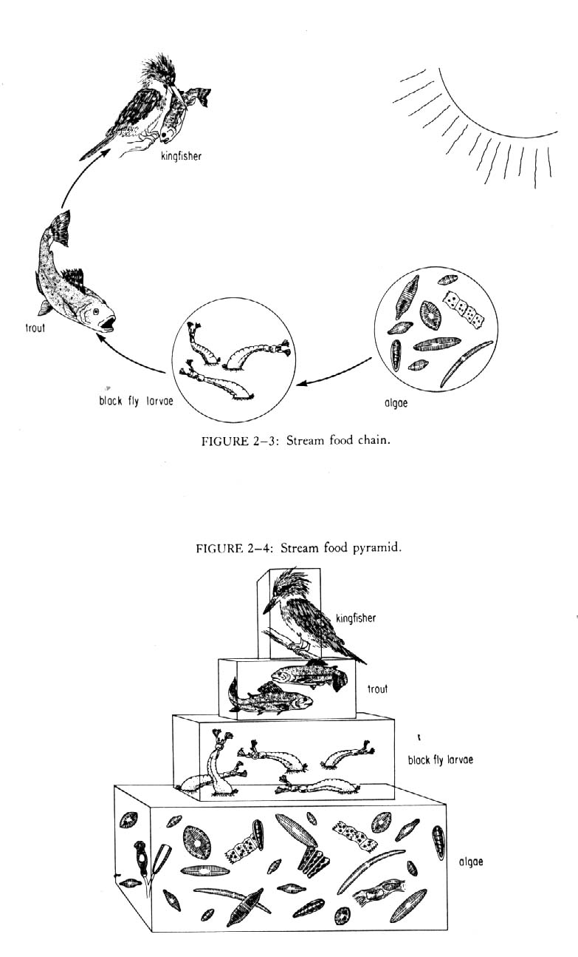Source: http://kingfish.coastal.edu/biology/sgilman/generalfoodweb.jpg

