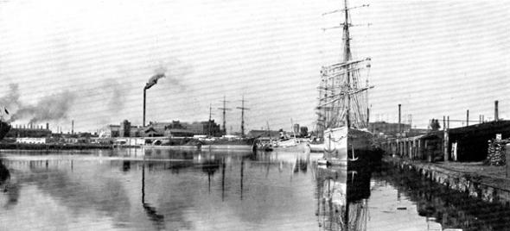
Effects of Factories
1. How do you think the environment has been changed by factories?

2. How does this activity affect water quality?

3. What effects can this have on aquatic ecosystems?
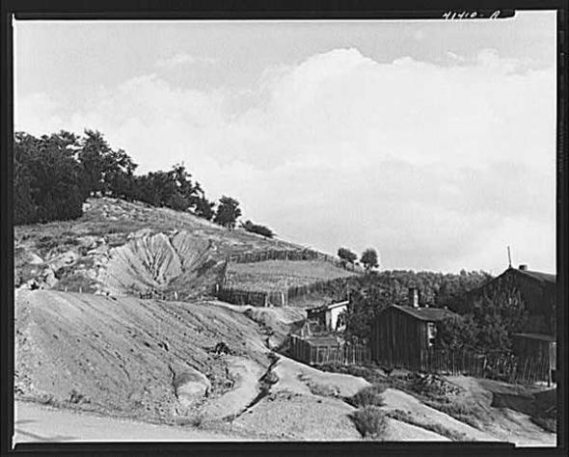
Effects of Mining
1. How do you think the environment has been changed by mining?

2. How does this activity affect water quality?

3. What effects can this have on aquatic ecosystems?

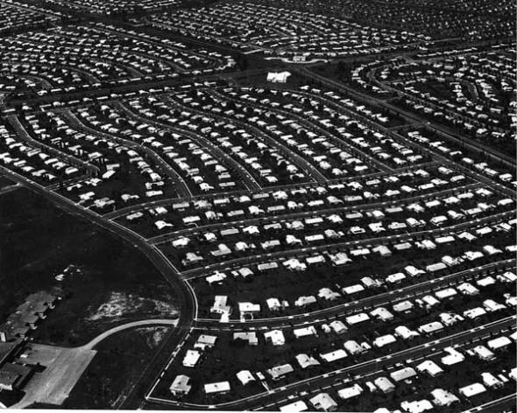
Effects of Housing Developments
1. How do you think the environment has been changed by housing developments?

2. How does this activity affect water quality?

3. What effects can this have on aquatic ecosystems?
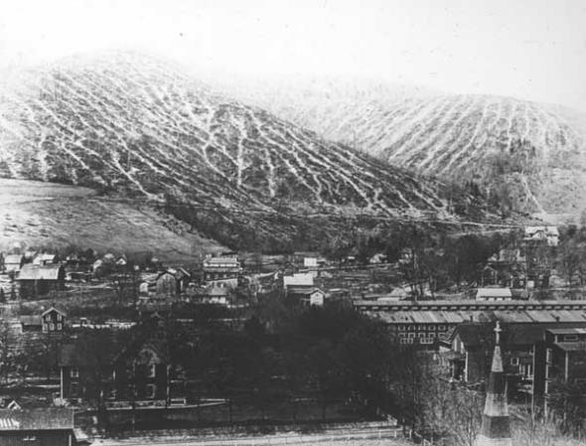
Effects of Logging
1. How do you think the environment has been changed by logging?

2. How does this activity affect water quality?

3. What effects can this have on aquatic ecosystems?

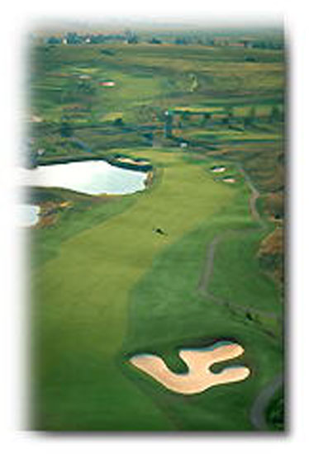
Effects of Golf Courses
1. How do you think the environment has been changed by golf courses?

2. How does this activity affect water quality?

3. What effects can this have on aquatic ecosystems?

Source of all images above: http://explorepahistory.com/lesson_procedure.php?id=26
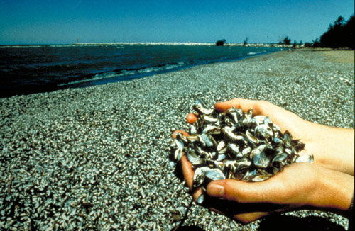
Effects of Invasive Species
The photo above shows zebra mussels found in Lake Erie. It is generally agreed upon by scientists that zebra mussels entered the Great Lakes from water dumped by large ocean-going ships from Europe. Many invasive species have common characteristics that make them adaptable to new environments. The zebra mussel could inhabit most of the fresh waters of the United States. It may affect a variety of native aquatic species and even entire ecosystems.
Many power plants and water users have spent millions of dollars cleaning out zebra mussels from their facilities, and installing devices to keep zebra mussels out and to monitor for them. These costs get passed along to the consumers.
- What is an invasive species?
- How can zebra mussels affect aquatic ecosystems in Pennsylvania?
- How do you think we can prevent the spread of zebra mussels in Pennsylvania’s waters?

Photo source: www.shipwreckexplorers.com/images/invasive/zebra%20mussels.jpg

