Oil Spill Simulation 1
Objective: To simulate an oil spill and its effects on animal life.

Materials:
- cooking oil
- old newspapers to cover lab work area
- swatches of various imitation animal fur and/or feathers (e.g., rabbit fur, bird feathers, down feathers)
- two square or round containers of tap water
- dishwashing liquid
- balloons
- funnel
- straight pin
- paper towels

CAUTION: Put on lab aprons and non-latex gloves and tie back long hair before beginning this activity. Cover work area with newspaper.

1. Observe the dry feathers and fur and illustrate what the feathers and/or fur look like in your journal. The journal page should be set up similar to the following chart:

Natural Fur or Feather | Fur or Feather After Oil Spill | Fur or Feather After Oil Spill Clean Up

2. Put the feather or fur into the clean water. Observe whether the fur or feather can float and how it looks on the water.
3. Remove the feather or fur from the water and put the balloon in the water. Carefully use a stick pin to puncture the balloon under the water to simulate the bursting of a tanker. Observe what you see now.
4. Then, put one of the feathers down in the oily water, and observe and illustrate what the feather or fur looks like. Is the feather or fur floating or sinking? How does it feel different?
5. Begin rescuing the “animals” by using a paper towel to clean the oil from the feather/fur. Pour about 20 drops of the liquid dishwashing liquid in the other container of clean water.
6. To remove some of the oil, place the feathers or fur into the clean container and wash them with soapy water. After you have cleaned the “animals,” observe what the “animals” look like now and draw on the chart.
7. Answer the following questions in your science journal:
- What ideas did you come up with on how to best clean up the spill?
- What are some ways we can protect our environment from man-made disasters such as oil spills?
- How does a large oil spill affect the biodiversity of a marine ecosystem?

Oil Spill Simulation 2

Objective: to simulate an oil spill and its effects on animal life.
Materials:
- two ice cubes
- two sealable plastic bags
- three plates
- four cotton balls
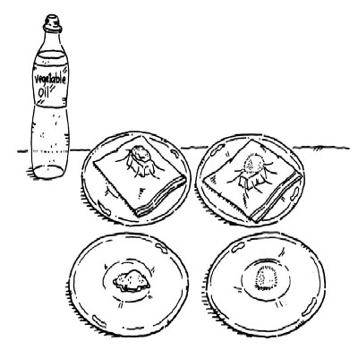
Learn how oil spills damage our environment with
this classroom experiment.
- vegetable oil

Step 1: Put an ice cube into each of the plastic bags. Squeeze out all the air from the bags, and seal them. Put each of the bags on a plate.
Step 2: Soak two cotton balls in vegetable oil. Put one of the cotton balls on top of one of the plastic bags. Make sure the cotton ball stays on top of the ice cube. Put the other oil-soaked cotton ball on an empty plate.
Step 3: Put a dry cotton ball on the other plastic bag (on top of the ice cube). Place another dry cotton ball on the empty plate next to the oil-soaked cotton ball.
Step 4: Let everything sit for 20 minutes. Pick up the two dry cotton balls—the one that is on the ice cube, and the one that isn’t. Are they about the same temperature, or is one colder?
Step 5: Pick up the two oil-soaked cotton balls—the one that is on the ice cube, and the one that isn’t. Does one feel colder?
Step 6: Pick up the two cotton balls that are on the ice cubes. Does one feel colder? What does this tell you about the connection between oil and keeping warm?
Imagine that those cotton balls are birds, otters, or other animals. When an animal is soaked with oil, it gets cold, just like the oil-soaked cotton balls. That’s because oil destroys the natural insulation that animals have.
Whenever there’s an oil spill, animals die for many reasons. Some are poisoned by the oil. Birds starve to death because they cannot fly to catch food. Some animals die because their food has been killed by the oil. And some animals freeze to death because oil has destroyed their ability to stay warm.
Cleaning Up Oil Spills
Oil spills threaten humans, animals, and the environment. It is important to begin cleaning up an oil spill as quickly as possible. Clean-up crews often place long plastic or rubber barriers around the spill, so it cannot spread further. They may try to vacuum up the oil, using special machines. Crews may also try to absorb the oil, using sponge-like pads.

\

Source of Oil Spill Simulation 2: http://tlc.howstuffworks.com/family/environmental-activities2.htm

