Line Plot Practice

Use the line plot below to answer
questions 1 – 5.

Quiz Score Results
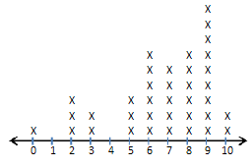
Number of Points out of 10.

Use the line plot below to answer
questions 6 – 9.

Hours Slept on Saturday Night

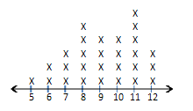
Hours Slept

- How many students scored exactly 2 points on the quiz?
  - 0
  - 1
  - 2
  - 3
- How many points did the largest group of students score?
  - 7
  - 8
  - 9
  - 10
- How many students scored 10 points?
  - 2
  - 3
  - 5
  - 6
- How many students scored 3 points or fewer?
  - 2
  - 3
  - 5
  - 6
- How many students scored exactly 4 points?
  - 0
  - 1
  - 3
  - 4
- What do the two x’s above the 6 mean?
  - 6 people slept 2 hours
  - 2 people slept 6 hours
- How many people are represented in the line plot?
  - 6
  - 12
  - 14
  - 28
- What was the median number of hours slept on Saturday night?
  - 6
  - 7
  - 8
  - 9
- How many people slept for 6 or 7 hours on Saturday night?
  - 2
  - 3
  - 5
  - 6

Line Plot Practice—KEY

Use the line plot below to answer
questions 1 – 5.

Quiz Score Results
Number of Points out of 10

Use the line plot below to answer
questions 6 – 9.

Hours Slept on Saturday Night

Hours Slept

- How many students scored exactly 2 points on the quiz?
  - 0
  - 1
  - 2
  - 3
- How many points did the largest group of students score?
  - 7
  - 8
  - 9
  - 10
- How many students scored 10 points?
  - 2
  - 3
  - 5
  - 6
- How many students scored 3 points or fewer?
  - 2
  - 3
  - 5
  - 6
- How many students scored exactly 4 points?
  - 0
  - 1
  - 3
  - 4
- What do the two x’s above the 6 mean?
  - 6 people slept 2 hours
  - 2 people slept 6 hours
- How many people are represented in the line plot?
  - 6
  - 12
  - 14
  - 28
- What was the median number of hours slept on Saturday night?
  - 6
  - 7
  - 8
  - 9
- How many people slept for 6 or 7 hours on Saturday night?
  - 2
  - 3
  - 5
  - 6

