What makes the data display misleading? List everything you find.

Sick Days Used by Person
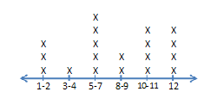
Number of Sick Days

Average Class Test Scores by Week
100
95
90
85
80
95
70
65
60
55
50
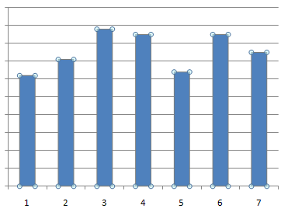
Week Number

Average High Temperature by Year
85
80
79
75
70
60
50
40
25
10
0
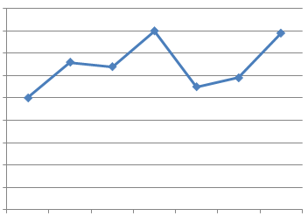
2000 2002 2003 2006 2007 2009 2010

_____________________________________

_____________________________________

_____________________________________

_____________________________________

_____________________________________

_____________________________________

_____________________________________

_____________________________________

_____________________________________

_____________________________________

_____________________________________

_____________________________________

_____________________________________

_____________________________________

_____________________________________

