Representation | Relation? | Function? | Supporting Reasons
 | Yes
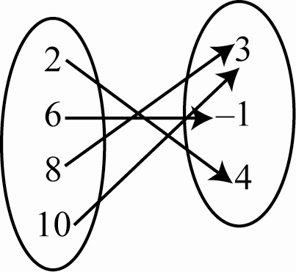 | Yes
A B  −4 0  2 8  5 9  2 3  6 1 | Yes
Set A = {(2,9), (3,4), (3,0), (8,2)} | Yes

Key
Representation | Relation? | Function? | Supporting Reasons
 | Yes | No | Horse is paired with two elements in the second set.
 | Yes | Yes | Each element in domain is paired with one and only one element in range.
A B  −4 0  2 8  5 9  2 3  6 1 | Yes | No | 2 is paired with 8 and 3.
Set A = {(2,9), (3,4), (3,0), (8,2)} | Yes | No | 3 is paired with two elements in a range.

