1. Use the grid below to draw your own geometric figure. Label the coordinates of the vertices of your figure. Place each vertex on a whole number intersection, rather than between intersections. Use a colored pencil. Sample Answer Square ABCD

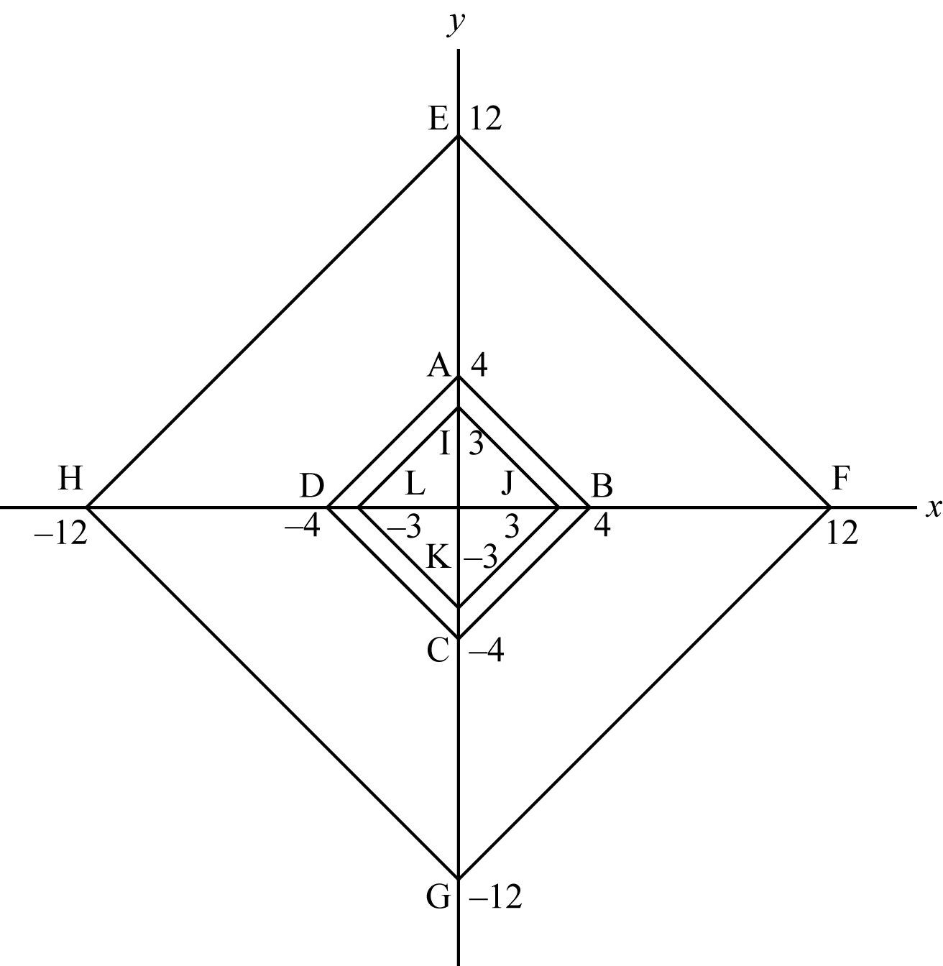

2. Stretch your figure by a factor of 3. Label the coordinates of the new vertices. Use a different colored pencil than you did in #1. Sample Answer: Original Square ABCD   
A (0, 4), B (4, 0), C (0, -4), D (-4, 0);   
Stretched Square EFGH   
E (0, 12), F (12, 0), G (0, -12) H (-12, 0)

3. Shrink your figure by a factor of. Label the coordinates of the new vertices. Use a different colored pencil than you did in #1 and #2. Shrunken Square IJKL   
I (0, 3), J (3, 0), K (0, -3), L (-3, 0)