Exit Ticket (KEY)

- Draw and label a box-and-whisker plot (including the entire 5-number summary) for the following data set:

34, 26, 37, 35, 42, 25, 25, 28, 13

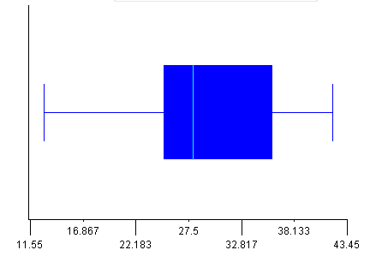
Median: 28
Minimum: 13
Maximum: 42
Lower Quartile: 25
Upper Quartile: 35

- For the data set above, state whether the mean, median, or mode best represents the data. Explain your reasoning.

Mean: 29.4
Median: 28
Mode: 25

Both the mean and median are good representations of this data. Median may be the best, however, as the mean is a bit high.

