Stem-and-Leaf / Box-and-Whisker Plots

Example data set: 32, 21, 44, 64, 12, 19, 25, 2, 51, 57, 35, 25, 17, 48, 49, 51

Stem-and-Leaf Plot
In this example, the leaves represent the ones place for each corresponding tens place. Each leaf represents a separate value in the data set.
Stem | Leaves
0 | 2
1 | 2 7 9
2  In this example, the numbers in the stem represent the tens place of each value in the data set. | 1 5 5
3 | 2 5
4 | 4 8 9  Key:  3|2 = 32
5 | 1 1 7
6 | 4

The key in a stem-and-leaf plot shows how to read the stem and leaves.

Box-and-Whisker Plot
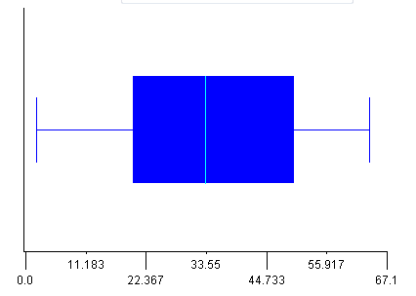
Upper Quartile
Lower Quartile
Median
A box-and-whisker plot must be shown on a number line with consistent intervals. In this example, the number line starts and ends with values that will allow the full range of the data set [2, 64].
Maximum
Minimum

