Analysis and Interpretations (KEY)

Review the following situations and representations. Write conclusive statements for each situation. Make predictions where appropriate.

- Kara records the distances walked per week by a random sample of sixth grade students. A histogram representing the data is shown below.
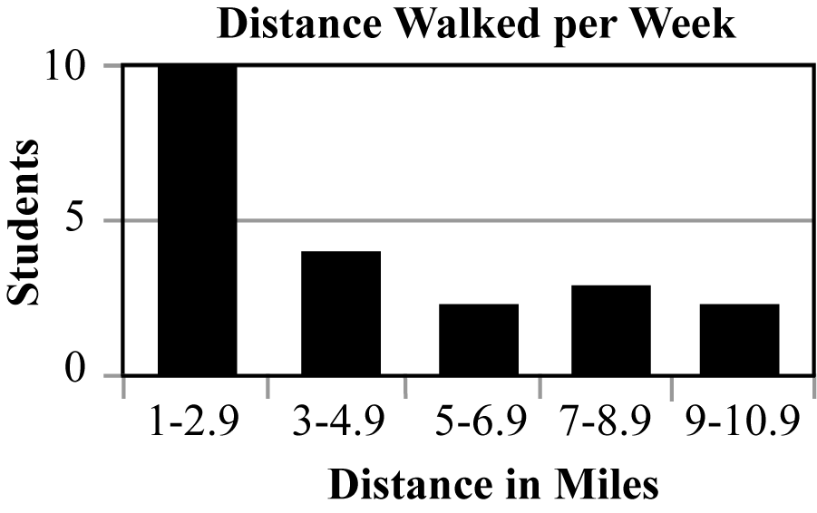

Example conclusion – More students walked between 1 and 2.9 miles than any other interval.
Example prediction – Two or fewer students would walk 11 or more miles.

- Terrence surveyed the entire population of high school teachers to determine the preferred vehicle brand. He recorded the preferences using the circle graph below.

Example conclusion – A total of 28 teachers were surveyed.
Example prediction – A new survey of 70 teachers would show about 30 teachers for Chevrolet.

