Analysis and Interpretations

Review the following situations and representations. Write conclusive statements for each situation. Make predictions where appropriate.

- Kara records the distances walked per week by a random sample of sixth grade students. A histogram representing the data is shown below.
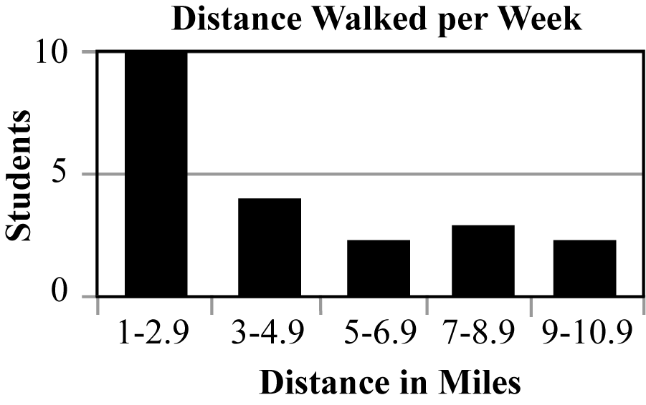

- Terrence surveyed the entire population of high school teachers to determine the preferred vehicle brand. He recorded the preferences using the circle graph below.

