Graphing Inequalities
To graph a linear inequality in two variables, follow these steps:
- Use inverse operations to isolate the variable ___.
- Temporarily replace the inequality symbol with an ____________________ and graph the resulting line on a coordinate plane.
  - If the original inequality symbol is < or >, the line should be ________________.
  - If the original inequality symbol is ≤ or ≥, the line should be ________________.
- Choose a test point and substitute its x and y values into the original inequality. (It is often easiest to choose (___, ___) for your test point!)
  - If the resulting inequality is true, __________________________________.
  - If the resulting inequality is false, __________________________________.

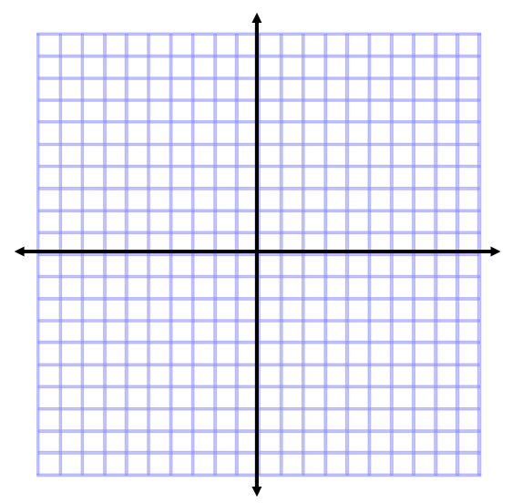
Graph the following inequalities.

- $y<\frac{2}{3}x+4$
- 6x + 3y ≤ 24
- x – y > 5
- 4y – 10x ≥ 8

- A movie theater sells adult tickets for $10.00 and child tickets for $6.25. Each night, the theater has a goal of selling at least $2,500 in movie tickets.

  - Let x represent the number of adult tickets sold and y represent the number of child tickets sold. Write an inequality showing how many of each type of ticket must be sold per night in order for the theater to reach its goal.

  - Graph the inequality.

  - If the theater sells 125 adult tickets and 200 child tickets, will it meet its nightly sales goal?
    - Explain how you can use your graph from part b to answer this question.

    - Explain how you can use your inequality from part a to answer this question.

