Systems of Inequalities
Graph the following systems of inequalities. Be sure your solution regions are clearly indicated!

- $y≥2x+2$
$$y<-x-1$$
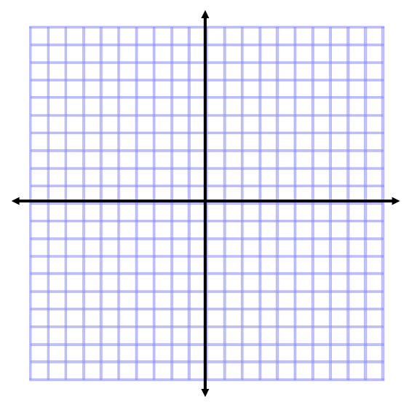

- $2x+y≤4$
$3x-y≥6$

- $y<2x+1$
$$y≥-x+3$$

- $x≤3$
$2x+y>2$

