**Matching**

**Match each graph in column 1 with an equation in column 2 and a table in column 3.**

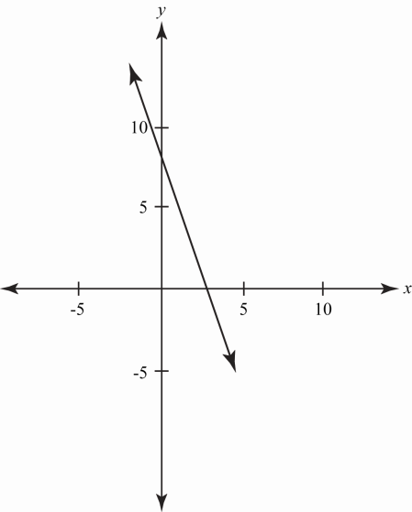

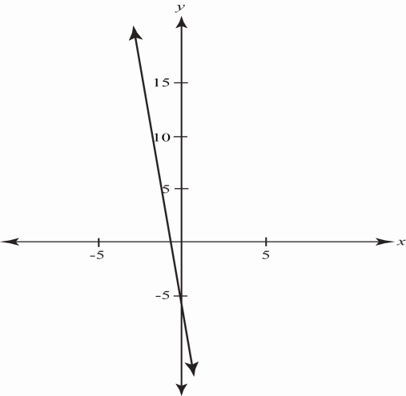

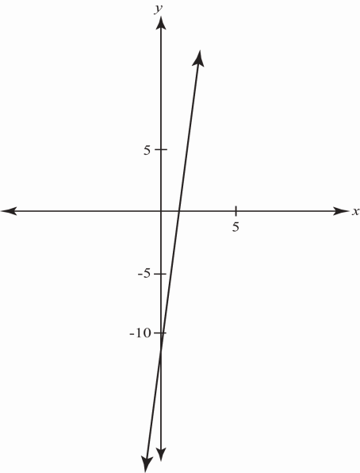

$$y=-8x-7$$

$$y=-2x+6$$

$$y=9x-12$$

|  |  |  |  |  |  |
| --- | --- | --- | --- | --- | --- |
| ***x*** | −3 | −1 | 0 | 3 | 6 |
| ***y*** | 12 | 8 | 6 | 0 | −6 |

|  |  |
| --- | --- |
| ***x*** | ***y*** |
| −4 | −48 |
| −1 | −21 |
| 0 | −12 |
| 2 | 6 |
| 5 | 33 |

|  |  |  |  |  |
| --- | --- | --- | --- | --- |
| ***x*** | −3 | 0 | 3 | 5 |
| ***y*** | 17 | −7 | −31 | −47 |