Two Similar Graphs (KEY)

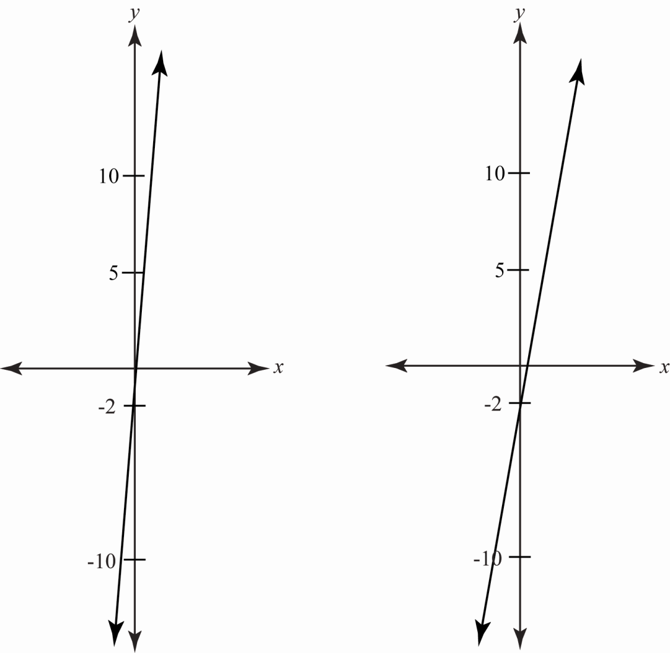

How are the graphs alike?
Both graphs are a straight line. Both are increasing, or have a positive slope.
How are they different?

The first graph crosses through the origin, meaning it has a y-intercept of 0. The second graph has a
y-intercept of −2. The first graph is slightly steeper, or has a slightly higher slope, than the second graph.

