Two Similar Graphs

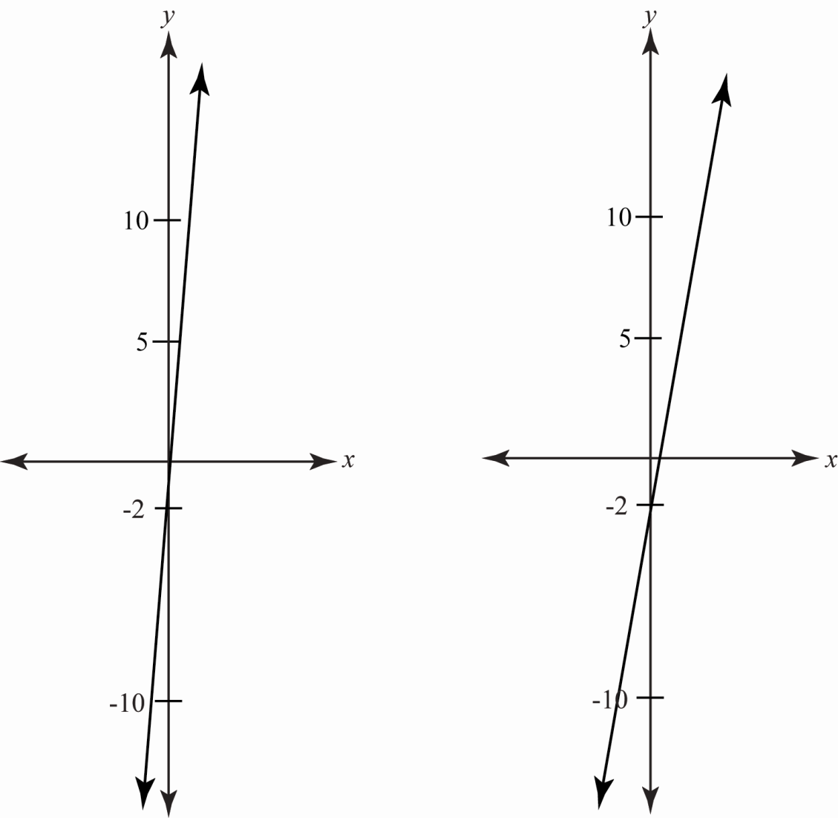

How are the graphs alike? _____________________________________________________________________________________
_____________________________________________________________________________________
How are they different?

_____________________________________________________________________________________
_____________________________________________________________________________________

