534 | Six hundred forty
1,002 | Forty-eight
19 | Three hundred sixty-two
4,444 | Nineteen hundred
79 | Five thousand four
9,100 | Sixty-seven
88 | One thousand thirty-three
497 | Eighty-one

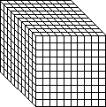

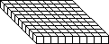

Group Order Activity - KEY
Number forms of base-ten block cards:
3,329 | 599
432 | 1,010
695 | 2,465
168 | 92
8,300 | 5,238
42 | 243
2,009 | 1,000
1,800 | 1,433

