Brownie Problems Name ____________________________

Answer each question by drawing a model. Explain your answer in a sentence or two.

- There are 6 brownies to share with 2 children. How many brownies does each child get?

- There are 2 brownies to share with 4 children. How many brownies does each child get?

- There are 3 brownies to share with 2 children. How many brownies does each child get?

- There are 3 brownies to share with 6 children. How many brownies does each child get?

- There are 6 brownies to share with 4 children. How many brownies does each child get?

Brownie Problems (KEY)
- There are 6 brownies to share with 2 children. How many brownies does each child get?
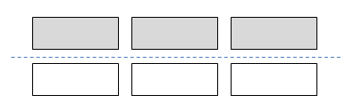
If you split 6 in half, you get 3. Each child gets 3 brownies.

- There are 2 brownies to share with 4 children. How many brownies does each child get?

To share 2 brownies with 4 children, each brownie needs to be split in half. Each child gets $\frac{1}{2}$ of a brownie.

- There are 3 brownies to share with 2 children. How many brownies does each child get?

Each child will get 1 whole brownie. Then there is 1 brownie left for the 2 children, so cut this brownie in half. Each child gets 1$\frac{1}{2}$ brownies.

- There are 3 brownies to share with 6 children. How many brownies does each child get?

Cut each brownie in half so there are 6 pieces. Each child gets $\frac{1}{2}$ of a brownie.

- There are 6 brownies to share with 4 children. How many brownies does each child get?

First cut each brownie in half. This makes 12 pieces. Each child gets 3 half pieces. So each child gets 1$\frac{1}{2}$ brownies.

