**Constant of Proportionality Name___________________**

**Find the constant of proportionality, *k*, represented by each of the following:**

|  |  |
| --- | --- |
| ***x*** | ***y*** |
| 1 | 4 |
| 2 | 8 |
| 3 | 12 |
| 4 | 16 |
| 5 | 20 |

1.

2. 

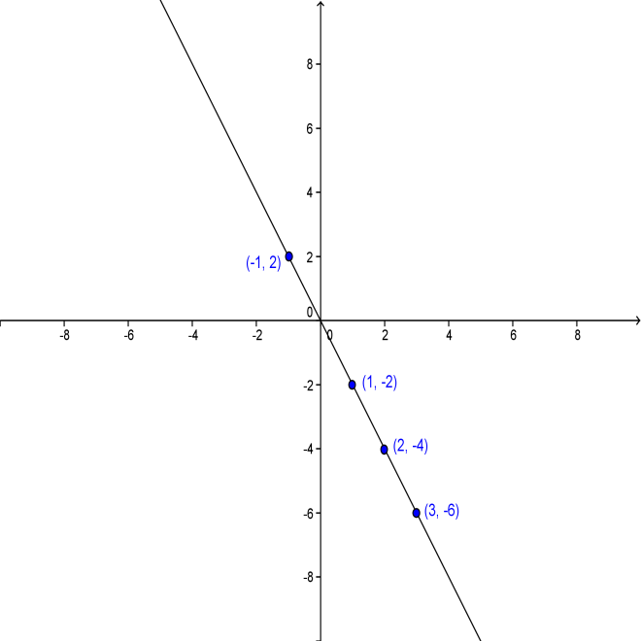

3. A cell phone company charges $0.30

for each call.

4.

|  |  |
| --- | --- |
| ***x*** | ***y*** |
| 2 | −12 |
| 5 | −30 |
| 7 | −42 |
| 10 | −60 |
| 12 | −72 |

5.

6. 

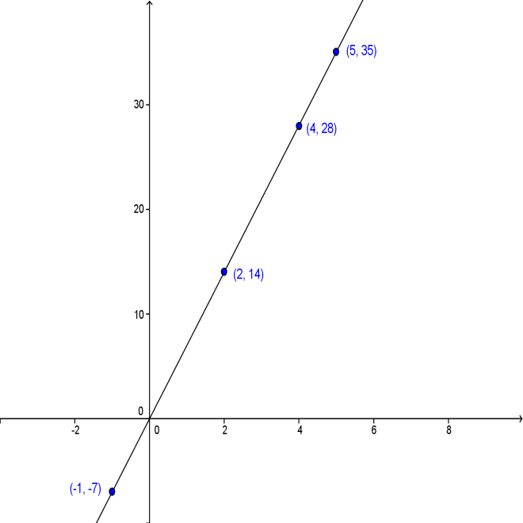

7. Andy can bake 2 cakes every 3 hours.

8.

**Constant of Proportionality - KEY**

1. 4
2. 12
3. 0.30
4. −2
5. −6
6. 1
$\frac{2}{3}$

7. 7