**Expansion Work Name______________________**

1. Represent the proportion  with an equation in the form *y* = *kx*. Identify the constant of proportionality.
2. Identify the constant, *k*, represented by the graph below:

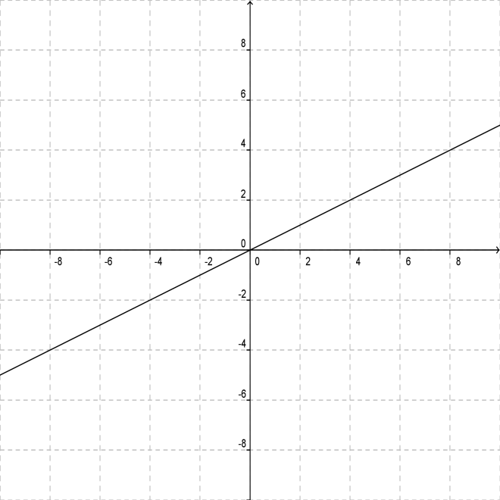

1. Create a table of values that represents a proportion with a constant rate of change of −4.5. Discuss the appearance of the graph of this proportion, including the point at which the graph crosses the *y*-axis.

**Challenge**

1. Provide an example of a nonproportional real-world relationship. Explain why it is nonproportional.
2. Provide an equation that is nonproportional.
3. Create a word problem that involves a real-world proportional relationship. Model the problem with at least 3 representations. Solve.

**Expansion Work (KEY)**

1. ; 
2. 0.5

|  |  |
| --- | --- |
| ***x*** | ***y*** |
| 0 | 0 |
| 1 | −4.5 |
| 2 | −9 |
| 3 | −13.5 |
| 4 | −18 |

*As each x-value increases by 1, the y-values decrease by 4.5. The graph will have a negative slope, falling from left to right. The graph will pass through the origin, or the point, (0, 0), indicating the presence of a proportional relationship.*

1. *The monthly cost of a phone service, which charges a flat rate of $32, plus $0.07 for each long distance minute used.*

*This situation is nonproportional because the cost is $32, even when no long distance minutes are used. In other words, y does not vary directly with x. The situation includes a y-intercept that does not equal 0. The graph of this relationship would pass through the point, (0, 32), not (0, 0). A proportional relationship always passes through the origin.*

1. 
2. *Alex secures 3 new clients every 2 years. According to this rate, how many years will it take him to secure a total of 40 new clients?*

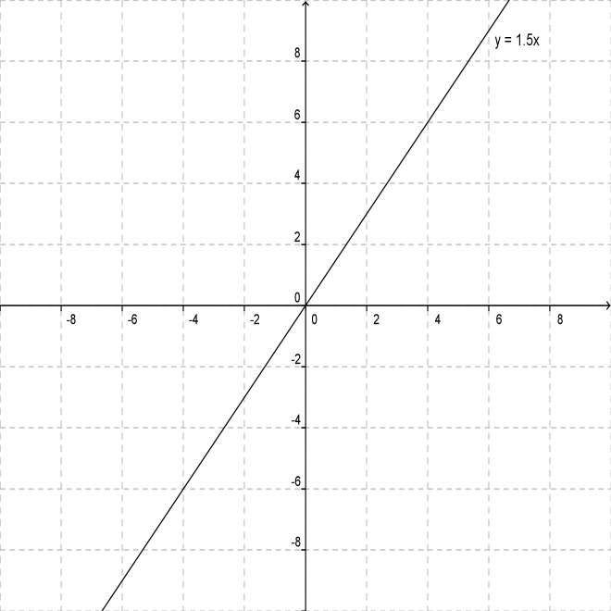



|  |  |
| --- | --- |
| ***x*** | ***y*** |
| 0 | 0 |
| 1 | 1.5 |
| 2 | 3 |
| 4 | 6 |
| 5 | 7.5 |
| 6 | 9 |

 years