**Lesson 1 Exit Ticket Name________________________**

1. Provide an example of a rate.
2. Provide an example of a proportion.
3. Represent the proportion  with an equation in the form *y* = *kx*. Identify the constant of proportionality.

**Solve.**

1. 112 oz = ____ c
2. 42 in = _____ ft
3. Avis pays a total of $312 every 6 months for her phone bill. How much will she have paid after 4 years?
4. It takes Olivia 5 weeks to write 2 grant proposals. Based on this rate, how many grant proposals can she write in one year?
5. Given the similar figures below, find the missing measurement and identify the constant of proportionality, *k*.

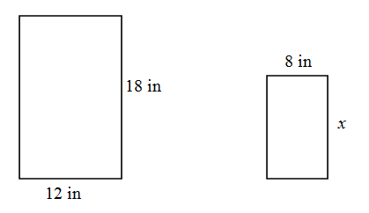

**Lesson 1 Exit Ticket - KEY**

1. 4 scoops per minute
2. 2/3 = 8/12
3. *x* = 36

*k* = 1/3

*y* = (1/3)*x*

1. 14 cups
2. 3.5 feet
3. $2,496
4. 20.8 proposals
5. *x* = 12 in.

*k* = 2/3