**Lesson 1 Small Group Practice Name___________________**

1. Given the equation, identify the constant of proportionality.
2. Given the graph below, identify the constant, *k*, and represent the proportion with an equation.

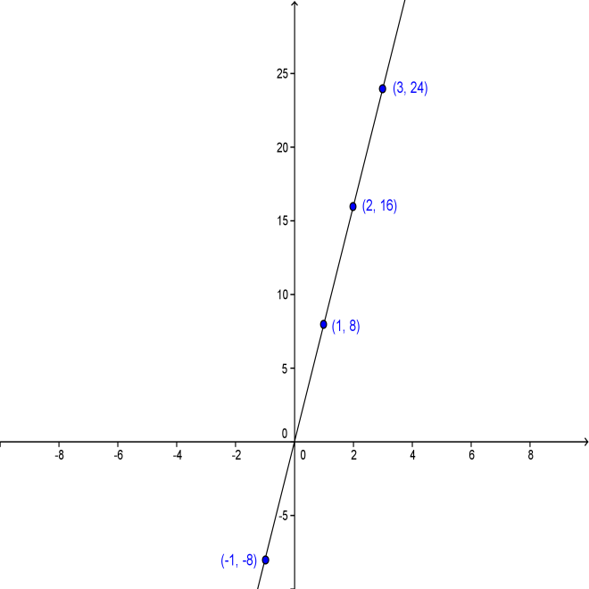

1. Solve:



1. Ana can buy 3 loaves of bread for $4.50. How many loaves can she buy with $15?
2. A map has a scale where 1 inch = 12 miles. How many inches will represent a distance of 72 miles?

**Lesson 1 Small Group Practice – KEY**

1. *k* = 3
2. *k* = 8

*y* = 8*x*

1. *x* = 20
2. 10 loaves
3. 6 inches