**Small Group Practice Name___________________**

**Determine whether each of the following represents a proportional relationship. Explain why or why not.**

1. 

|  |  |
| --- | --- |
| ***x*** | ***y*** |
| 0 | 0 |
| 1 | 7 |
| 2 | 14 |
| 3 | 21 |
| 4 | 28 |

1. $2600 for every 160 hours worked

$1800 for every 108 hours worked

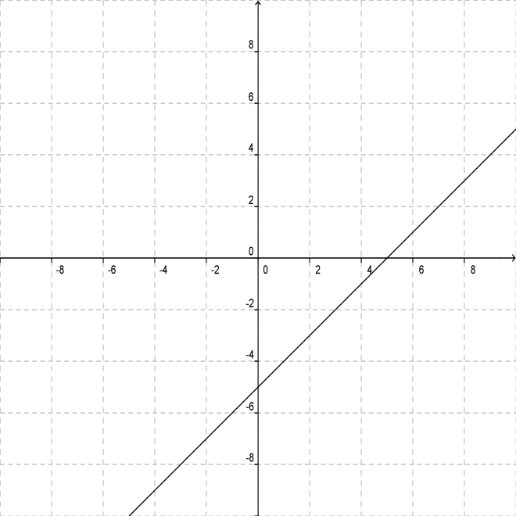

1. 

**Small Group Practice (KEY)**

**Determine whether each of the following represents a proportional relationship. Explain why or why not.**

1.  *Yes; the cross-products are equal.*

|  |  |
| --- | --- |
| ***x*** | ***y*** |
| 0 | 0 |
| 1 | 7 |
| 2 | 14 |
| 3 | 21 |
| 4 | 28 |

*Yes; the ratios of x-values to y-values are consistent, and the point*

*(0, 0) is on the graph.*

1. $2600 for every 160 hours worked

$1800 for every 108 hours worked *No; $\frac{2600}{160}≠\frac{1800}{108}$.*

 *No; the line does not cross through*

*the origin.*

1.  *Yes; the equation is in the form y = kx.*