On the first coordinate plane:

Figure 1:

(1, 2)
(5, 2)
(3, 7)

Figure 2:

(6, 2)
(8, 2)
(8, 12)
(6, 12)

Figure 3:

(10, 6)
(14, 6)
(14, 10)
(10, 10)

On the second coordinate plane:

Figure 4:

(1, 1)
(4, 1)
(6, 3)
(5, 6)
(2, 7)

Figure 5:

(7, 4)
(9, 1)
(11, 3)
(14, 4)
(10, 7)
(8, 6)

Figure 6:

(1, 12)
(1, 10)
(6, 7)
(8, 9)
(12, 8)
(14, 11)
(10, 14)
(3, 14)

Coordinate Geometry - KEY
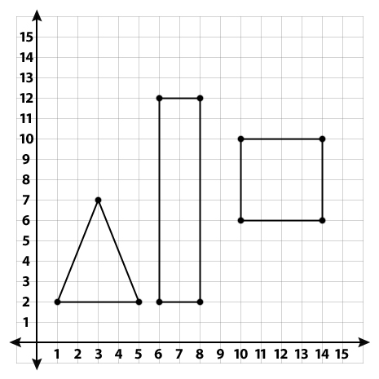
3
2
1
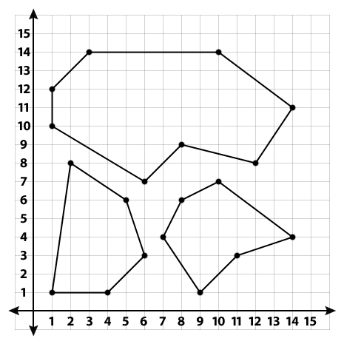
6
5
4

