Lesson 3 Exit Ticket
Jen asked 12 fifth graders how many cats they own. Her results are shown in the pictograph below.
Use the data from the pictograph to create a bar graph. Be sure to add labels and titles.
Number of Cats Owned by 5th Graders
Cats Owned | 5th Graders
4
3
2
1
0
Key: = one 5th Grader
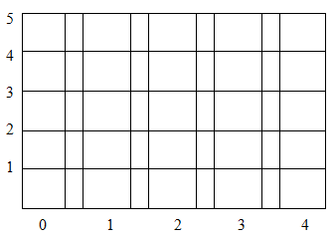
In the space below, create a table or tally chart to show the same data as the pictograph. Be sure to add labels and titles.

Lesson 3 Exit Ticket (KEY)
Jen asked 12 fifth graders how many cats they own. Her results are shown in the pictograph below. Use the data from the pictograph to create a bar graph. Be sure to add labels and titles.
Number of Cats Owned by 5th Graders
Cats Owned | 5th Graders
4
3
2
1
0
Key: = one 5th Grader
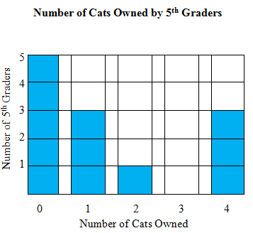
In the space below, create a table or tally chart to show the same data as the pictograph. Be sure to add labels and titles. (Answers may vary.)
Tally Chart
Number of Cats Owned by 5th Graders
# Cats Owned | # of 5th Graders
0
1
2
3
4

Table
Number of Cats Owned by 5th Graders
# Cats Owned | 0 | 1 | 2 | 3 | 4
# of 5th Graders | 5 | 3 | 2 | 0 | 3

