Shape Pattern Examples Name___________________

Shape Patterns | Why Is It a Shape Pattern? Explain.
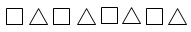
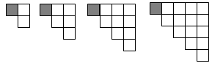
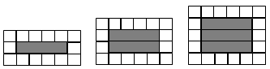
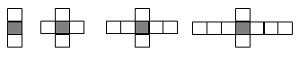
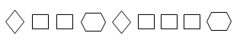
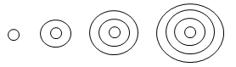

Shape Pattern Examples (KEY)

Shape Patterns | Why Is It a Shape Pattern? Explain.
 | Common rule: Alternate square, triangle, square, triangle, etc.
 | Common rule: Add a column of squares to the right that has one more square than the right column of the previous figure.
 | Common rule: Add a vertex to each figure.
 | Common rule: Add a hexagon to each figure.
 | Common rule: Increase bottom row by 1 dot; then fill in upper rows accordingly.
 | Common rule: Add 1 shaded rectangle to each center.
 | Common rule: Add 1 square to the left and 1 to the right each time.
 | Common rule: Add another square to the series of squares between each diamond and hexagon.
 | Common rule: Add one outer circle to each figure.
 | Common rule: Add 1 parallelogram to the left and bottom of each figure.

