DISPLAY 1

Sequence 1: (1, −2), (2, −5), (3, −8), (4, −11)

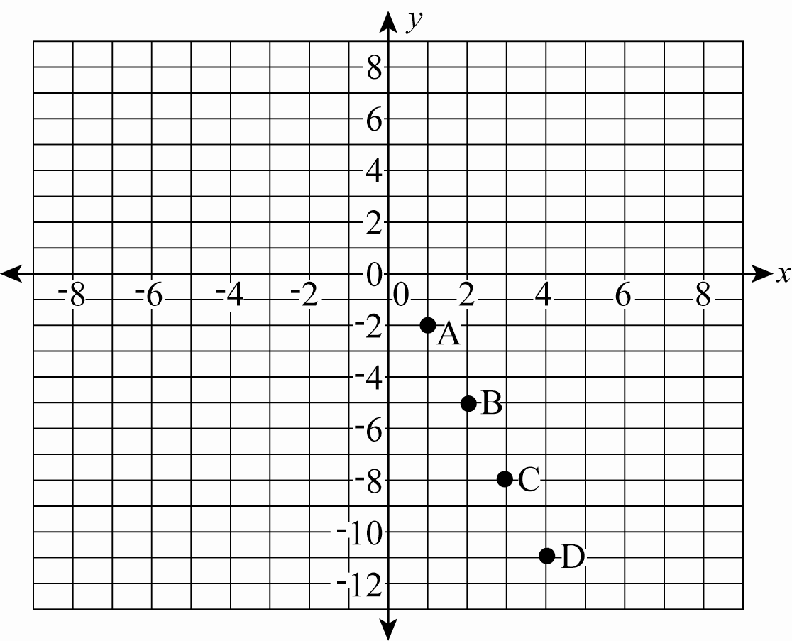

DISPLAY 2

Sequence 2: (1, 12), (2, 15), (3, 19), (4, 24)

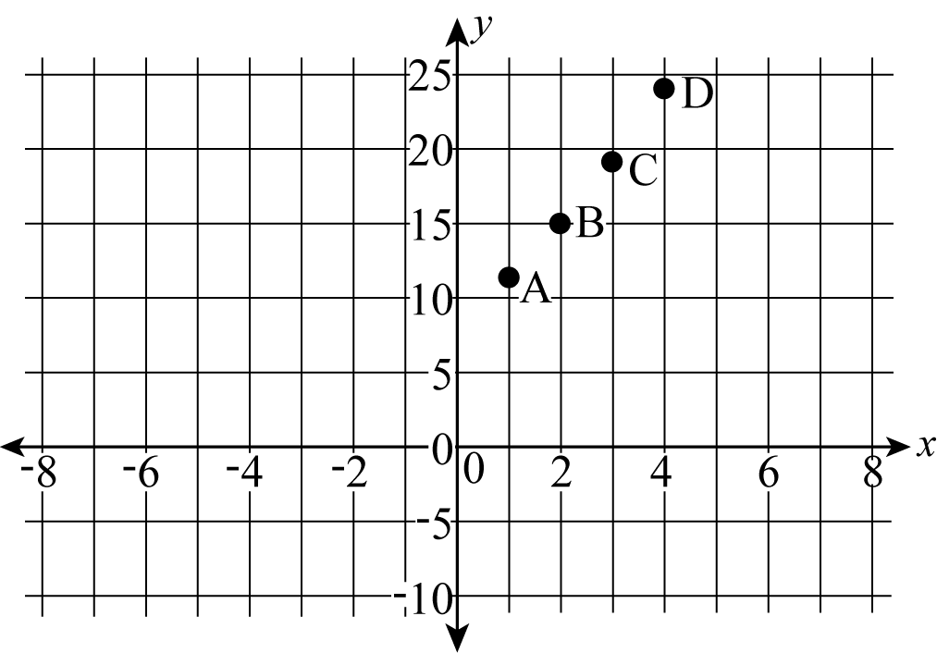

DISPLAY 3

Sequence 3: (1, 7), (2, 15), (3, 23), (4, 31), (5, 39)

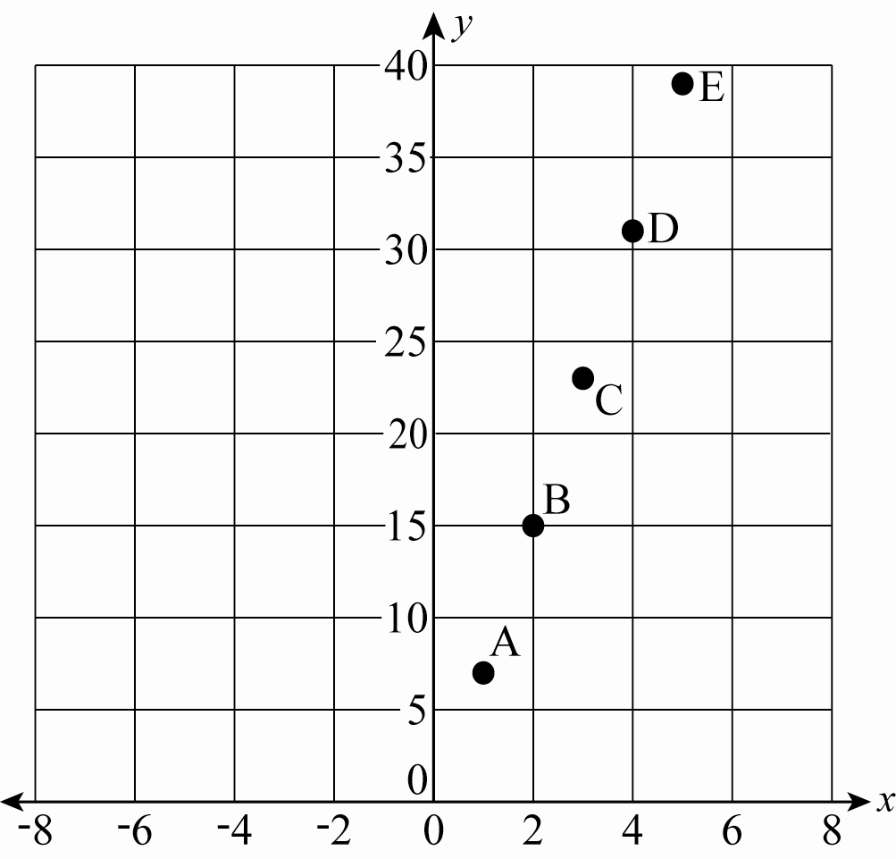

DISPLAY 4

Sequence 4: (1, 1), (2, 4), (3, 9), (4, 16), (5, 25)

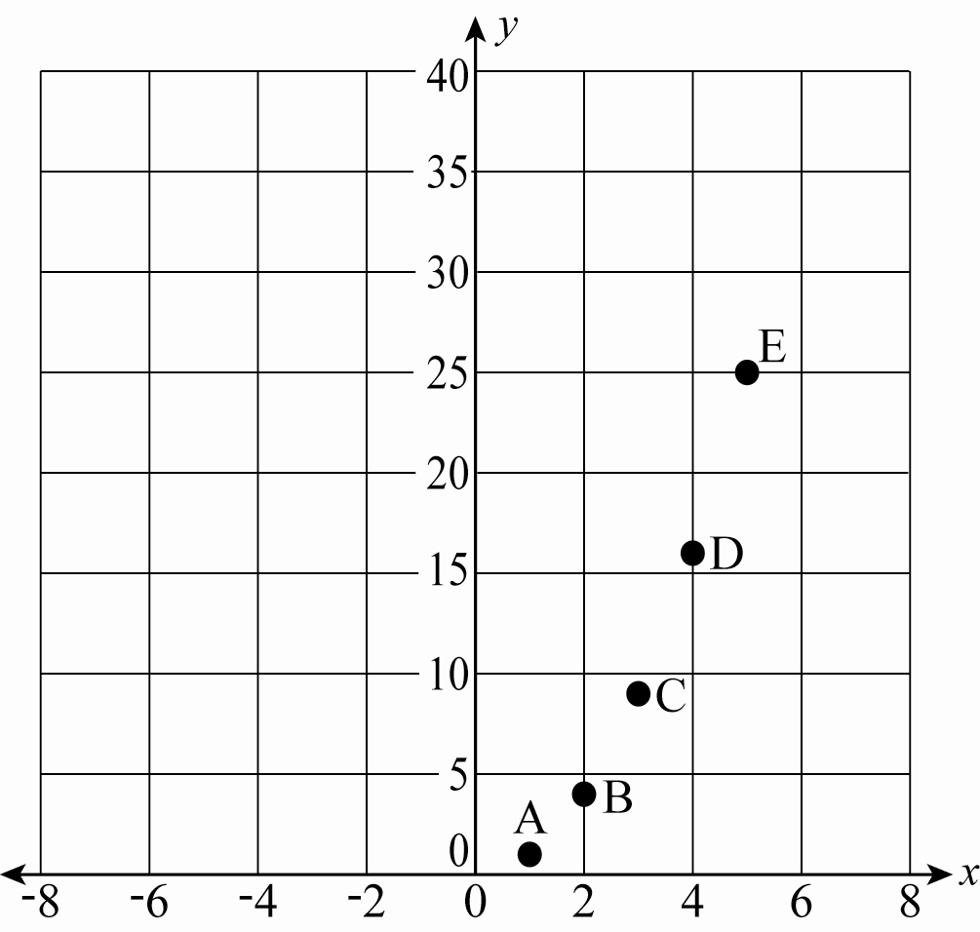

DISPLAY 5

Sequence 5: (1, 1), (2, 8), (3, 27), (4, 64)

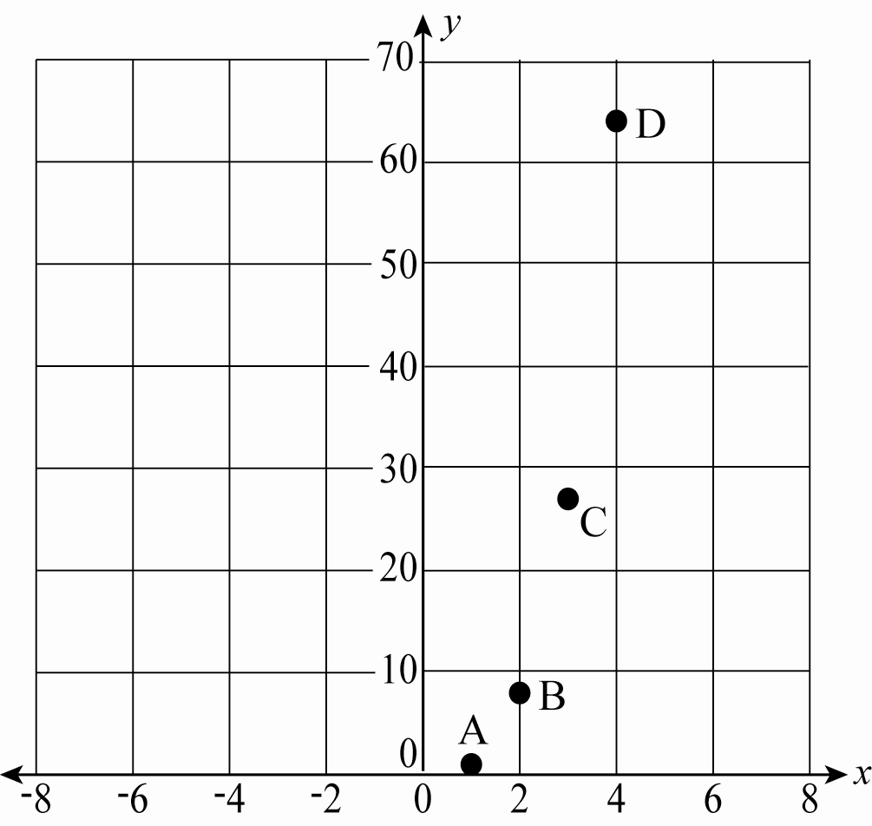

DISPLAY 6

Sequence 6: (1, 3), (2, 9), (3, 27), (4, 81)

