Function Exploration

For each function, complete the x/y table. Then graph the points, connect them, and extend the graph in a way that continues the trend or pattern.

- y = 3x + 1

x | y
−1
0
1
2

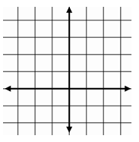

- y = x² – 3

x | y
−1
0
1
2

- y = $\frac{4}{x}$ + 2

x | y
1
2
4
8

Function Exploration - KEY

For each function, complete the x/y table. Then graph the points, connect them, and extend the graph in a way that continues the trend or pattern.

- y = 3x + 1

x | y
−1 | −2
0 | 1
1 | 4
2 | 7

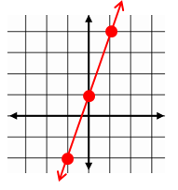

- y = x² – 3

x | y
−1 | −2
0 | −3
1 | −2
2 | 1
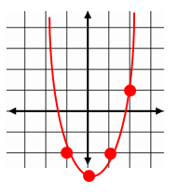
- y = $\frac{2}{x}$ + 1

x | y
1 | 3
2 | 2
4 | 1$\frac{1}{2}$
8 | 1$\frac{1}{4}$

