**Rise Over Run**

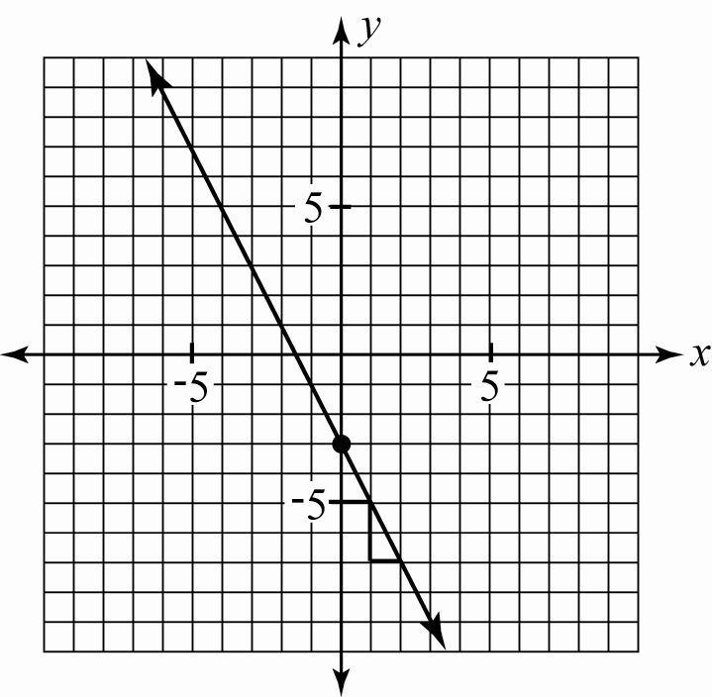

**Linear Equation 1 - Example**

*y* = −2*x* − 3

* What is the *y*-intercept? −3
* How do you know? That is the point on the *y*-axis at which the line crosses the *y*-axis.
* What is the slope? −2
* Show rise over run on the graph. Then explain in words. Down 2, right 1.

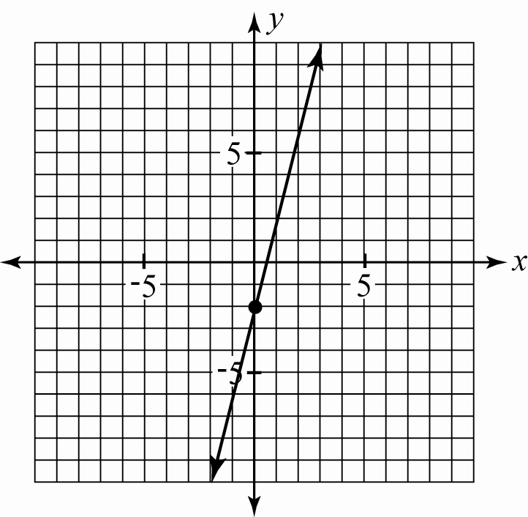

**Linear Equation 2**

*y* = 4*x* − 2

* What is the *y*-intercept?
* How do you know?
* What is the slope?
* Show rise over run on the graph. Then explain in words.

**Linear Equation 3**

*y* = *x* + 1

* What is the *y*-intercept?
* How do you know?
* What is the slope?
* Show rise over run on the graph. Then explain in words.

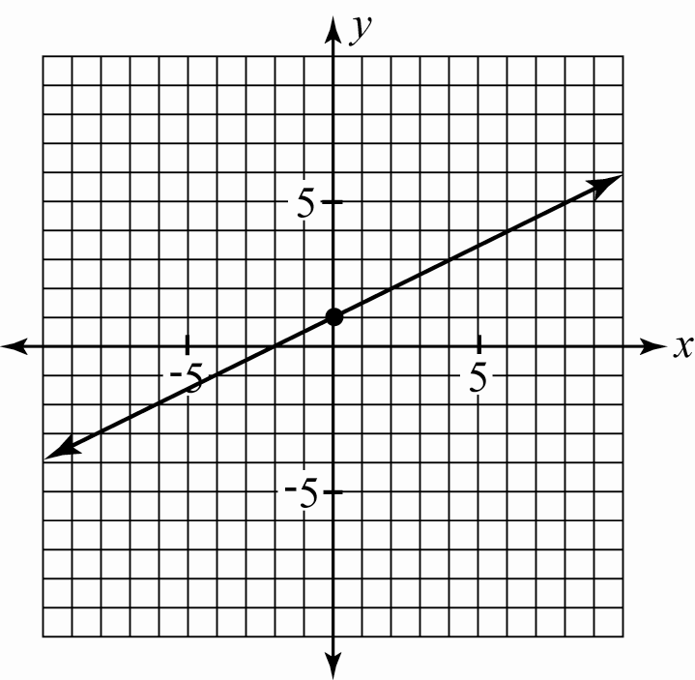

**Rise Over Run - KEY**



**Linear Equation 1 - Example**

*y* = −2*x* − 3

* What is the *y*-intercept? −3
* How do you know? That is the point on the *y*-axis at which the line crosses the *y*-axis.
* What is the slope? −2
* Show rise over run on the graph. Then explain in words. Down 2, right 1.



**Linear Equation 2**

*y* = 4*x* − 2

* What is the *y*-intercept? **−2**
* How do you know? **The line crosses the *y*-axis at −2.**
* What is the slope? **4**
* Show rise over run on the graph. Then explain in words. **Up 4, right 1.**

**Linear Equation 3**

*y* = *x* + 1

* What is the *y*-intercept? **1**
* How do you know? **The line crosses the *y*-axis at 1.**
* What is the slope? $\frac{1}{2}$
* Show rise over run on the graph. Then explain in words. **Up 1, right 2.**

