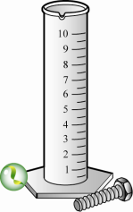
Volume of Objects Using Water Displacement Name__________________

Materials needed: graduated cylinder
water
small objects (marble, rock, small bolt, nickel, lump of clay) for each group
Procedure: 1. Fill the graduated cylinder halfway with water.
You will notice that the water level does not go straight across. The water level is concave and is referred to as a meniscus. When you are reading the water level in a graduated cylinder, you want to be sure to read it in the center at eye level.
2. Estimate the volume of each object and record on the chart below.
3. Record the level of water on the chart below. The units are milliliters (mL).
4. Carefully lower the object into the graduated cylinder.
5. Read the new water level. Be sure to view it at eye level.
6. Record the new water level on the chart below.

Before you begin, predict which object will have the greatest volume. ________________________
Object | Estimated  volume of the object  (cm³) | Water level  at the start  (mL) | Water level after you put  the object in  the water(mL) | Volume of the object  (cm³)
Marble
Rock
Small bolt
Nickel
Lump of clay
Lump of clay reshaped

Was your original prediction correct? YES or NO

Which object had the greatest volume? _______________________________ How do you know?
____________________________________________________________________________________

Is this what you expected? Explain. _______________________________________________________

____________________________________________________________________________________

