Comparing Decimals with Blocks
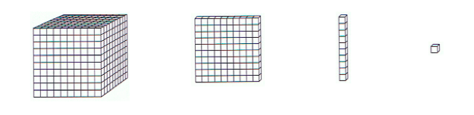
ones tenths hundredths thousandths
In order to compare the decimal numbers below, build them with the base-ten block representations shown above. You can visually see which is greatest and which is least. Try to find patterns and strategies as you practice.
- 0.14□0.1
- 0.14□0.2
- 0.43□0.5
- 0.43□0.403
- 0.38□0.04
- 0.386□0.4
- 0.5□0.50
- 0.9□0.866
- 2.304□3.124
- 1.82□1.673

Comparing Decimals with Blocks (KEY)
ones tenths hundredths thousandths
In order to compare the decimal numbers below, build them with the base-ten block representations shown above. You can visually see which is greatest and which is least. Try to find patterns and strategies as you practice.
- 0.14 > 0.1
- 0.14 < 0.2
- 0.43 < 0.5
- 0.43 > 0.403
- 0.38 > 0.04
- 0.386 < 0.4
- 0.5 = 0.50
- 0.9 > 0.866
- 2.304 < 3.124
- 1.82 > 1.673

