Cut out the words and glue them to the correct 3D shape.
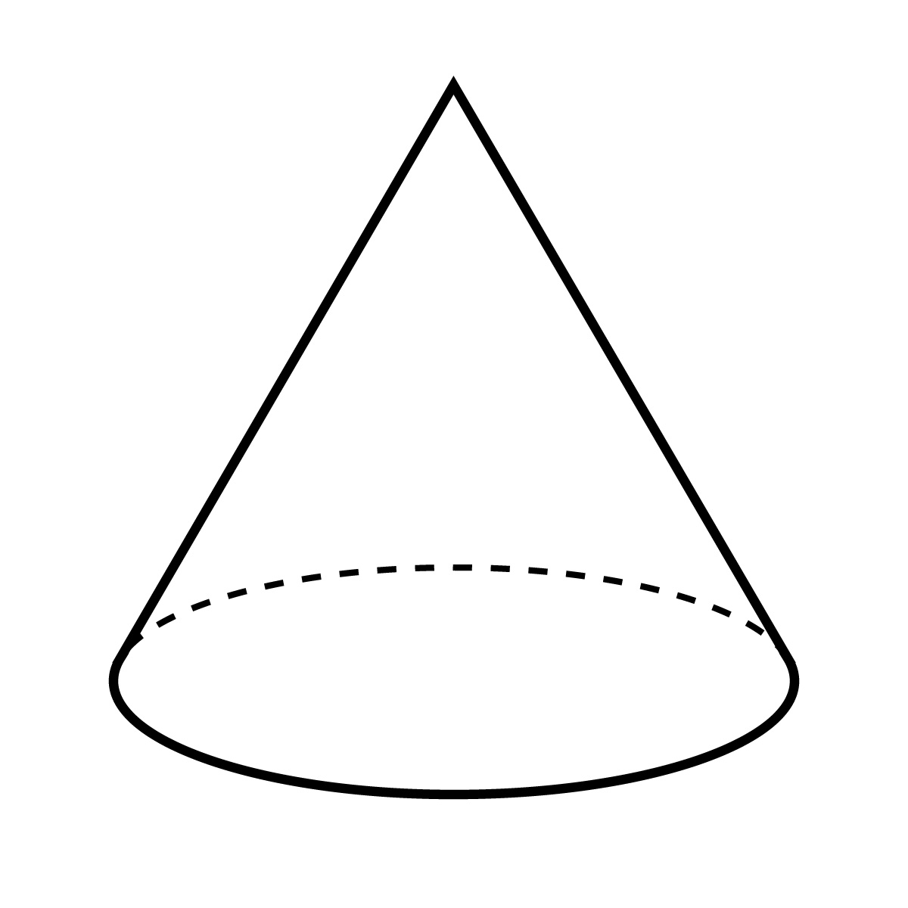
Rectangular Prism
Cube
Cone
Cylinder
Name _____________________________

Cut out the words and glue them to the correct 3D shape.
Cone

Cylinder
Cube
Rectangular Prism
Key

