Name _________________________________________
What Shape Is It?

Materials:
1 bag with 2D and 3D shapes
1 recording sheet per pair

Directions:
- Give each pair of students a paper bag filled with several 2D and 3D shapes.
- Partner 1 reaches into the bag and grabs one shape in his/her hand.
- Partner 1 leaves his/her hand in the bag and describes what s/he is holding without looking. (e.g., It has 3 sides. It has 3 corners.)
- After describing the shape to Partner 2, Partner 1 tells the shape s/he thinks is in his/her hand. (e.g., I think I have a triangle.)
- If the answer is correct, the group colors in 1 shape on the recording sheet. NOTE: Students may color in any shape on the recording sheet.
- The shape is put back in the paper bag and Player 2 takes a turn.
- The activity is over when all of the shapes have been colored in or time is up.

If every shape on the recording sheet is in the bag, you could have students color in the matching shape on the recording sheet. In this case, if the shape has already been colored, they do not color in a shape.

What Shape Is It?
Color 1 shape on your board when you and your partner correctly guess the shape from the bag.
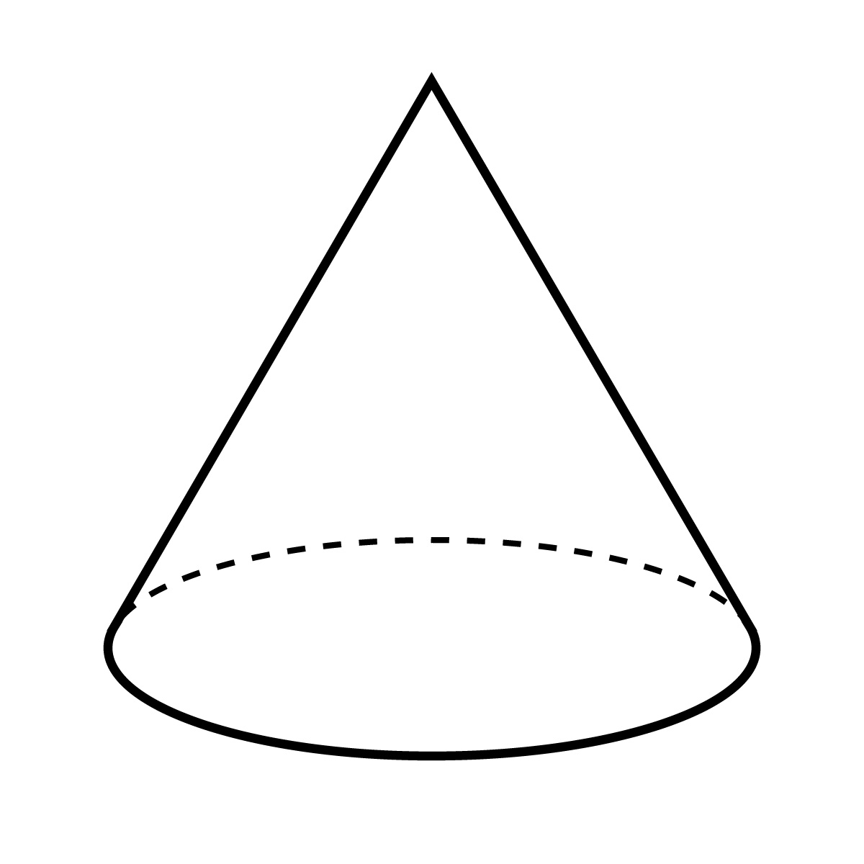

Partner 1 ______________________________________

Partner 2 ______________________________________

What Shape Is It?
Color 1 shape on your board when you and your partner correctly guess the shape from the bag.

Partner 1 ______________________________________

Partner 2 ______________________________________

