Expanded Form Worksheet Name: ______________________

Use pictures of base-ten blocks to show 247.

In 247,

What is the value of the 2? ________
What is the value of the 4? ________
What is the value of the 7? ________

Write the number 247 in expanded form.

247 = ________ + ________ + ________

Write these numbers in expanded form.
526 | 526 = ________ + ________ + ________
420 | 420 = ________ + ________ + ________
705 | 705 = ________ + ________ + ________
999 | 999 = ________ + ________ + ________

Which of these shows 539 in expanded form?

- 50 + 30 + 9
- 500 + 30 + 9
- 530 + 9
- 500 + 39
Expanded Form Worksheet KEY

Use pictures of base-ten blocks to show 247.
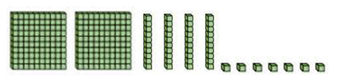
In 247,
What is the value of the 2? 200
What is the value of the 4? 40
What is the value of the 7? 7
Write the number 247 in expanded form. 200 + 40 +7

Write these numbers in expanded form.
526 | 526 = 500 + 20 + 6
420 | 420 = 400 + 20
705 | 705 = 700 + 5
999 | 999 = 900 + 90 + 9

Which of these shows 539 in expanded form?

- 50 + 30 + 9
- 500 + 30 + 9
- 530 + 9
- 500 + 3

