Color the shape you would see if you pressed the block into clay.

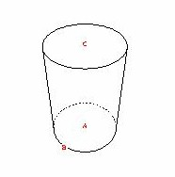

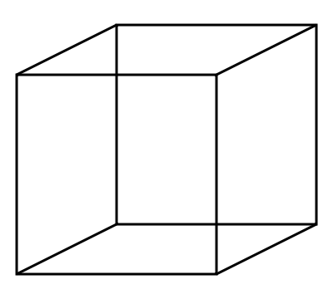

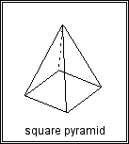

Draw a line to match the objects to the blocks which are the same shape.

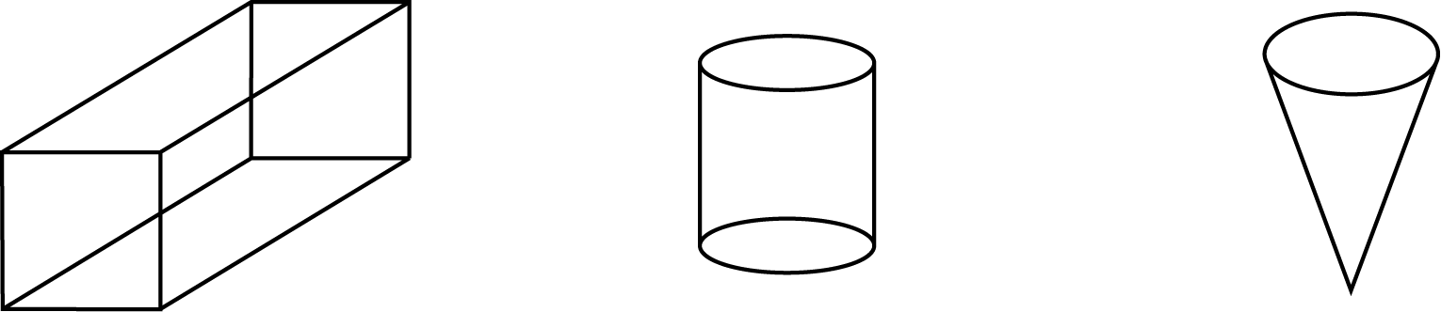

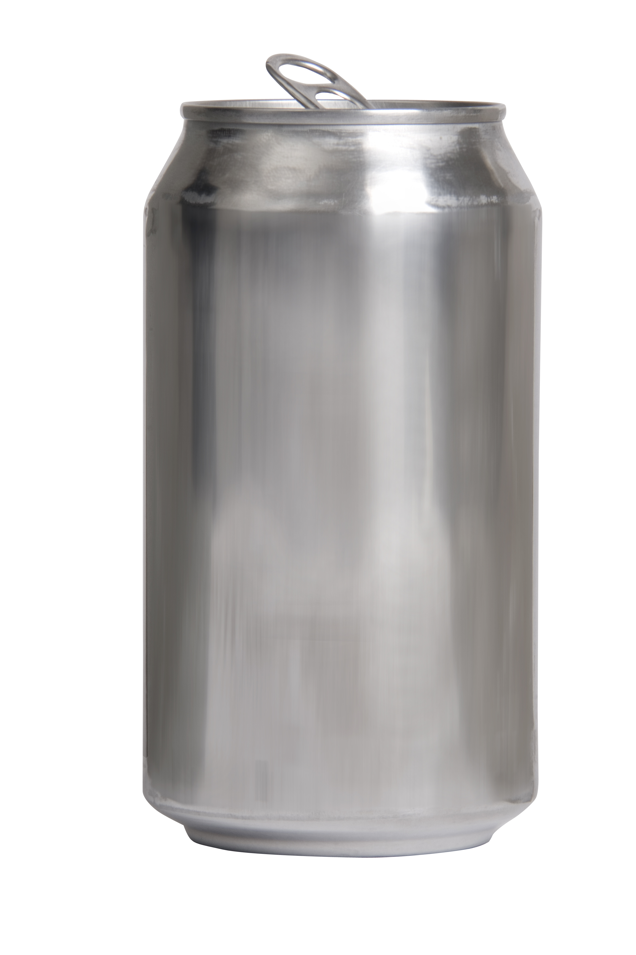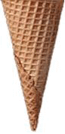

KEY
Color the shape you would see if you pressed the block into clay.

Draw a line to match the objects to the blocks which are the same shape.

