Bag | Word | Ten-Frame | Tallies | Numeral
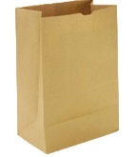
A
B
C
D
E
F
G
H
I
J
K
L
M

