One  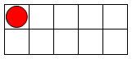  1 | Two  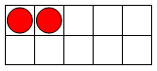  2 | Three  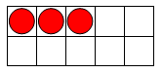  3 | Four  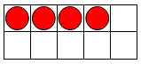  4 | Five  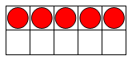  5
Six  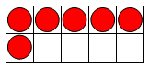  6 | Seven  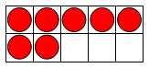  7 | Eight  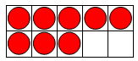  8 | Nine  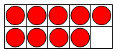  9 | Ten  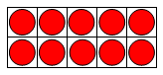  10

